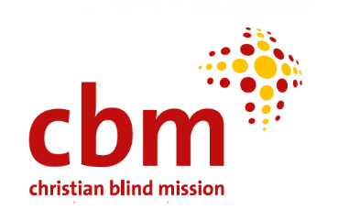



STRENGTHENING INTEGRATION OF PEOPLE CENTRED EAR AND HEARING CARE IN ZAMBIA 2024-2028

Feasibility Study Report

2023

|  |  |
| --- | --- |
| Christoffel Blindenmission Deutschland e.V. (CBM)  CBM Christoffel Blindenmission Christian Blind Mission e.V. CBM is an international Christian development organisation, committed to improving the quality of life of persons with disabilities in the poorest communities of the world. Based on Christian values and more than 100 years of professional expertise, CBM addresses poverty as a cause and a consequence of disability. CBM works in partnership to create an inclusive society for all. The emphasis is on local capacity development in poorer regions of the world. This includes service delivery in the fields of healthcare, education, rehabilitation and livelihood development as well as organisational development of partner organisations.  Beit Cure Hospital (BCH)  The Beit Cure Hospital (BCH) is a recognized Zambian NGO and registered as a teaching hospital. The mission of the hospital is the healing of children with treatable physical disabilities and accordingly, the teaching hospital is equipped with disability specific departments. BCH is currently the only hospital in Zambia that can perform certain complex operations (such as artificial hip and knee joints and operations on the middle ear). BCH was already the local partner of a BMZ co-financed project in cooperation with CBM (project number: 2009.1578.5, project title: "Aufbau ohrenmedizinischer Dienste in Lusaka, Sambia"). For CBM, BCH is a reliable and strategic partner in Zambia.  **Authors of this report:**   * Arthur M Moonga * Aaron K Tembo * William Mutelekesha   **Suggested Citation**:  Moonga, A. M *et al*. (2023) Feasibility Study Report: Strengthening integration of people centred ear and hearing care in Zambia. CBM   * Designed by: Arthur Moonga * Photography: Dorothy Zulu | Disclaimer  This report is made possible by funding from CBM. The views and opinions expressed do not necessarily reflect those of CBM, or any other contributing organisation. Responsibilities for the contents of the report rests with the authors  Acknowledgements  We owe a particular debt of gratitude to Dr. Linda Kasonka, Country Director of CBM Zambia, and Ms. Slinganiso Homela, Programmes Manager of CBM Zambia. Their invaluable support and guidance were cornerstones in the foundational stages of this study. Profound appreciation is due to the staff at Beit CURE Hospital (BCH) for their unwavering technical support, without which the practical aspects of our research would have been untenable.  Special acknowledgement goes to our dedicated research team, whose expertise and diligence in conducting field studies, data analysis, and report compilation were invaluable. Their commitment in the face of various challenges ensured the thoroughness and accuracy of the research findings.  We would be remiss not to mention the heart of our study — the research participants. Their willingness to share personal experiences and time brought authenticity and depth to this report. We respect their courage and openness in discussing sensitive aspects of their lives, contributing significantly to the richness of our research.  Our reviewers, Emmanuel M. Masiye, Ms. Moonga Hambulo, and Mr. Yotam Mwale, deserve our sincere thanks for their meticulous feedback and constructive criticisms that significantly raised the caliber of our report.  Our collaborative efforts extended to several governmental bodies. We express heartfelt gratitude to the Ministries of Health, Education, Community Development and Social Services, and the Zambia Agency of Persons with Disabilities for their unparalleled cooperation. Their assistance in facilitating our access to crucial resources, staff, and facilities was indispensable in the practical realization of this research.  This report stands as a testament to the collective effort, shared expertise, and unified commitment from various quarters. To everyone involved, we offer our enduring appreciation and respect. |

Table of Contents

EXECUTIVE SUMMARY i

1.0 Introduction and Background 1

1.1 Introduction 1

1.2 Background and Rationale 1

2.0 Feasibility Study 1

2.1 Purpose of the Feasibility Study 1

2.2 Methodology 1

3.0 Context analysis 1

3.1 Overview of Ear and Hearing Problem 1

3.2 Stakeholder Analysis 1

3.3 Needs Assessment 1

3.4 Current Infrastructure and Resources 1

3.5 Policy and Legal Framework 1

3.6 Risk Analysis 1

4.0 Relevance Assessment 1

4.1 Identified bottlenecks 1

4.2 Alignment of the project initiatives with identified bottlenecks 1

4.3 Compatibility of norms and standards of the approach with target group’ needs 1

4.4 Conflict-Sensitive Design (Do-No-Harm Principle) 1

5.0 Coherence Assessment 1

5.1 Coherence of planned activities with human rights principles 1

5.2 Alignment with local and international guidelines/provisions 1

5.3 Synergies and linkages between the planned project and other interventions 1

5.4 Extent of value addition and duplication avoidance 1

6.0 Effectiveness Assessment 1

6.1 Plausibility of the impact theory of change 1

6.2 Potential negative effects 1

6.3 Appropriateness and sufficiency of methodological approach 1

6.4 Additional activities needed to increase the effectiveness. 1

6.5 Appropriateness of indicators to measure the planned changes 1

7.0. Efficiency Assessment 1

7.1 Adequacy of planned resources 1

8.0 Impact Assessment 1

9.0 Sustainability Assessment 1

10.0 Safeguarding and ethics assessment 1

11.0 Gender equality assessment 1

12.0 Monitoring and evaluation Assessment 1

13.0 Lessons learnt from the BMZ/CBM ENT and other projects. 1

14.0 Conclusions and Recommendations 1

14. 1 Conclusions 1

14.2 Recommendations 1

Appendices 1

Appendix 1: Feasibility Study Process 1

Appendix 2: Reviewed Documents 1

Appendix 3: Feasibility Assessment Criteria 1

Appendix 4: Sample sizes by region 1

Annexes 1

Annex 1: Context analysis 1

Annex 2: Tools 1

# EXECUTIVE SUMMARY

**Introduction**

The Feasibility Study Report evaluates the "Strengthening Integration of People-Centred Ear and Hearing Care in Zambia" project, planned for 2024-2028 by Christian Blind Mission and Beit CURE Hospital, with potential funding from the German Federal Ministry of Economic Cooperation and Development. This comprehensive assessment is pivotal for understanding the feasibility and potential challenges of enhancing ear and hearing care within Zambia, where a significant gap exists in this area. Globally, ear and hearing issues are a major health concern, with Zambia facing notable deficiencies in its healthcare infrastructure to address these needs. The project aims to improve the quality of life for individuals with or at risk of hearing loss by enhancing access to care, integrating ear and hearing services into the national health plan, and strengthening healthcare worker capacities through training and task-sharing, alongside robust advocacy and sustainable, evidence-based service implementation.

The planned project, spanning seven provinces and reaching 4.2 million people in both urban and rural Zambia, aims to comprehensively address the growing burden of hearing impairments that affect individual well-being and strain socio-economic structures. Focused on capacity building, it targets training 410 healthcare professionals in audiology and 60 teachers in identifying hearing loss in children. Additionally, the project encompasses community engagement, policy advocacy, research, and robust monitoring and evaluation to enhance health facility capabilities, conduct awareness campaigns, collaborate with policymakers, and contribute to research. Its significance lies in fostering a more inclusive health system, aiming to improve the quality of life for those affected by hearing loss and aligning with Zambia’s broader health objectives to achieve sustainable national and community health improvements.

**Feasibility Study**

The feasibility study commissioned by CBM is pivotal in assessing the potential impact, sustainability, and integration of the ear and hearing care project with existing health initiatives in Zambia. Employing a rigorous methodology, it combined qualitative and quantitative approaches within a mixed-methods framework to thoroughly evaluate the project's alignment with the specific needs of the Zambian population, its financial viability, and operational frameworks. Adhering to OECD/DAC evaluation criteria, the study not only validated the project's conceptual strength but also aimed to ensure its capability to deliver long-term, transformational health benefits. This comprehensive approach included desk reviews, in-depth interviews, focus group discussions, and observations, all conducted with strict adherence to ethical standards, including child safeguarding and gender equality. The study's meticulous process, from inception to execution, was designed to scrutinize the project's alignment with health priorities, the viability of approaches, and long-term sustainability, ensuring ethical and gender considerations are integrated throughout. The multistage cluster sampling and extensive stakeholder engagement further reinforce the study's goal of developing informed, viable, and impactful interventions for ear and hearing care in Zambia.

**Key findings**

**The Relevance Assessment** of the project underscores its critical alignment with the urgent ear and hearing needs in the targeted regions. Addressing identified bottlenecks like limited-service access, particularly in provinces like Luapula, Northern, and Eastern, the project plans to bridge service gaps, enhance public awareness, and tackle the shortage of trained professionals. Furthermore, it aims to counteract issues of social isolation, stigma, and discrimination through inclusive and transformative strategies. Recognizing policy and funding gaps, as well as capacity constraints among stakeholders, the project is set to bolster government capacity and strengthen advocacy and operational effectiveness. Its compatibility with target group needs is evident in its inclusivity, quality focus, community engagement, and adherence to international health equity norms. Additionally, the project’s conflict-sensitive design, based on the Do-No-Harm principle, emphasizes cultural sensitivity, capacity building, data privacy, and ethical standards, ensuring a respectful and sustainable approach to addressing the multifaceted challenges of ear and hearing health in these communities.

**The Coherence Assessment**: The coherence assessment reveals the project’s strong alignment with human rights principles, standards, and existing health initiatives. It emphasizes inclusion and participation, aligning with ongoing interventions by MOH and stakeholders like Beit Cure, and aims for value addition without redundancy. The project’s design integrates human rights principles, particularly in capacity building for a wide range of healthcare professionals and community advocates. This approach enhances the quality and accessibility of care and addresses societal barriers, including stigma and misinformation. The project's alignment with WHO guidelines, particularly in enhancing workforce capacity at the community level, is evident. Its objectives and activities align with the WHO's emphasis on training health workers and integrating ear and hearing care into primary healthcare. This alignment extends to supporting the SDGs, particularly in promoting good health and well-being, inclusive education, and reducing inequalities. The project also aligns with the Zambia NHSP 2022-2026 and the Zambia ENT Strategic Plan 2017-2021, focusing on strengthening healthcare systems and incorporating ENT services into Zambia’s broader healthcare system. Additionally, the project is designed to intertwine with existing frameworks of the MOE and MOH, enhancing sustainability and adherence to national standards. Its collaborative nature fosters a holistic approach, ensuring EHC is an integral component of broader health and education programs.

**Effectiveness assessment:** The project's theory of change, is plausible but contingent on factors like stakeholder commitment and health system adaptability. Potential negative effects identified include overburdening existing health systems, inequity in service accessibility, risk of unintended stigmatization, data privacy concerns, and creating unsustainable dependency. The project’s approach is culturally sensitive and aligns with a community-based strategy, integrating ear and hearing care into national health plans for sustainability. However, it needs continuous adaptability and monitoring. Additional activities such as public-private partnerships, technology integration, and counselling services are suggested to enhance effectiveness. The appropriateness of the indicators is generally good, but requires refinement for specificity, measurability, and alignment with project goals, including timelines and sustainability measures.

**The Efficiency Assessment** of the project evaluated its strategic approach to resource utilization and management, assessing the project's potential to achieve its objectives economically. The analysis confirms that the budget allocation is feasible, with most of the key staff in health and education ministries already trained in certain provinces, allowing the project to focus on strengthening capacities in unaddressed areas. Beit Cure Hospital, with its extensive experience in ENT services and strategic partnerships, is a crucial player in the project, enhancing institutional capacity. The project leverages existing personnel within the Ministry of Health, providing additional training to those already employed, thereby efficiently utilizing existing resources and infrastructure. This approach maximizes the use of available human resources and ensures the dissemination of expertise throughout the healthcare system. The project's duration of four and a half years is considered sufficient to complete the necessary training and implementation phases, drawing on lessons from the successful BMZ/CBM ENT Project. This structured timeline balances training needs with the rollout of services, providing a realistic timeframe for achieving the project's objectives and ensuring its overall success in delivering sustainable ear and hearing care services.

**Impact Assessment:** The training of healthcare workers and teachers has the potential to bring about a wide-ranging and positive impact on healthcare, education, and communities, particularly in the context of ear and hearing care. Trained professionals can more effectively detect early signs of ear and hearing issues in children, allowing for timely interventions and prevention. By integrating ear and hearing care into educational settings, accessibility is increased, benefiting a diverse population, including underserved communities. Additionally, these professionals can raise awareness about ear and hearing health, leading to greater emphasis on preventive measures and regular check-ups. Improved hearing health may also enhance educational performance. Moreover, this initiative can help reduce health disparities, ensuring equal access to early intervention and support. The influence of trained professionals extends beyond the project timeline, promoting sustainability and lasting community impact.

**Sustainability assessment findings:** The sustainability of the results and impacts of the ear and hearing care intervention, as informed by the feasibility study, hinges on a multifaceted approach encompassing structural, economic, and social considerations. By building operational capacity of health facilities, financial resource allocation, community engagement, and capacity building of staff within the target regions, the project is well-positioned to ensure its long-term sustainability. Positive changes in societal attitudes, gender dynamics, and the role of community networks contribute to lasting impacts. Risks can be effectively mitigated through diversified funding sources, legal provisions, and sustained community sensitization efforts, ultimately securing the sustainability of the project's changes in Zambia's ear and hearing care services.

**Safeguarding and Ethics Assessment:** The feasibility study intricately outlines the program's robust framework, emphasizing safeguarding, ethics, and human rights, particularly for individuals with disabilities. Recommendations include a comprehensive ethical reorientation for medical staff, accentuating child protection, and integrating ethics deeply into healthcare curricula, ensuring sustainable ethical practices. The program champions gender balance and inclusive access to services, necessitating broad awareness of comprehensive safeguarding policies. It highlights the essential role of advocacy and governmental engagement for national scale-up, preserving ethical and human rights standards. Concerns around varied understanding of child safeguarding among staff are addressed through universal training initiatives, extending to all involved teams. The program's commitment to ethical integrity is further cemented by obtaining all requisite approvals for research and public reporting, reinforcing a transparent, ethical, and human-rights-aligned approach throughout its operations.

**Gender equality assessment:** Beit Cure Hospital and CBM have policies in place to promote gender equality and respect human rights. CBM's policy aligns with international human rights law and national laws in the countries where they operate. This ensures that their programs uphold fundamental human rights principles. CBM is also dedicated to fostering a deeper understanding and application of key international conventions and treaties, such as the Convention on the Rights of Persons with Disabilities (CRPD), the Convention on the Elimination of Discrimination Against Women (CEDAW), and the Convention on the Rights of the Child (CRC). These conventions focus on promoting equality, non-discrimination, and human rights. In both its BMZ/CBM ENT and planned programs, the organization commits to collecting and reporting data by age and sex, enabling the monitoring of gender-specific outcomes.

**Monitoring and evaluation system assessment findings**

The MOH relies on its Health Management Information System (HMIS) to collect vital healthcare data, including information on Ear, Nose, and Throat (ENT) services. However, the system's limited capacity to capture a comprehensive set of indicators has raised concerns regarding its ability to offer a holistic view of ENT service utilization and to monitor progress toward specific healthcare goals in this domain. Consequently, the current Monitoring and Evaluation (M&E) system for ENT services faces challenges in providing effective oversight. To mitigate these limitations, the program can improve data quality through capacity-building efforts, streamline reporting processes in collaboration with the MOH, explore complementary data sources, and establish regular monitoring and feedback mechanisms. This holistic approach aims to strengthen the feasibility and utility of the existing M&E system, fostering a culture of evidence-based practice within the healthcare infrastructure.

**Lessons learnt****:** Effective stakeholder engagement, especially with health ministries, is critical for aligning with national healthcare priorities and securing support. Awareness raising within communities is essential due to significant gaps in knowledge about ENT services, highlighting the need for proactive outreach and education. Utilizing existing healthcare personnel for training optimizes resource use, while strategic budget planning, as demonstrated by Beit Cure Hospital’s role, enhances project feasibility. Challenges like overburdening health systems, service accessibility inequities, potential stigmatization, data privacy issues, and creating unsustainable dependencies are identified as areas for attention. The project’s duration, following previous successful models, suggests adequacy for training and implementation. Emphasizing public-private partnerships, technology integration, and incorporating holistic counselling services are additional strategies to enhance effectiveness, with a focus on adaptable strategies and robust indicators to ensure efficiency and achievement of healthcare objectives.

**Conclusion**

Key findings highlight the project's relevance in addressing limited service access, professional shortages, social isolation, stigma, and policy gaps. It plans to enhance public awareness, strengthen advocacy, and improve operational effectiveness, adhering to international health equity norms and employing a conflict-sensitive, culturally sensitive design. The coherence assessment reveals the project’s alignment with human rights principles, WHO guidelines, and national health initiatives, emphasizing inclusion, capacity building, and innovative service delivery. The effectiveness assessment, while confirming the project's plausibility, notes potential challenges and suggests enhancements, including public-private partnerships and technology integration. The efficiency assessment confirms feasible budget allocation, leveraging existing resources for capacity building. The impact assessment anticipates significant improvements in healthcare, education, and community awareness. Sustainability findings emphasize a multifaceted approach for long-term viability, while safeguarding and ethics assessments underscore commitments to ethical practices and human rights. Gender equality is a focal point, aligning with international conventions. The monitoring and evaluation system assessment identifies limitations in the current HMIS and suggests improvements for a more effective system. Lessons learned stress the importance of stakeholder engagement, strategic planning, and adaptable strategies for achieving healthcare objectives.

**Recommendations**

1. **Mitigate Health System Overburdening**: Employ strategic resource management, task-shifting, technology integration, and incremental implementation of activities.
2. **Reduce Service Accessibility Inequity**: Utilize a mobile healthcare model supplemented by telehealth services to reach underserved areas.
3. **Combat Potential Stigmatization**: Implement inclusive communication and education strategies to normalize hearing impairments and reduce stigma.
4. **Enhance Data Privacy Measures**: Establish a comprehensive data protection framework, including adherence to strict laws, regular staff training, and secure data systems.
5. **Prevent Unsustainable Dependency**: Focus on local capacity building and gradual reduction of external support to foster self-reliance in healthcare services.
6. **Implement Community-Led Monitoring**: Use community stakeholders for data collection via digital tools, ensuring effective, timely, and cost-efficient data gathering.
7. **Refine Qualitative Indicators**: Clearly define and quantify qualitative indicators using structured surveys and specific benchmarks.
8. **Ensure Measurable and Achievable Outcomes**: Define specific, quantifiable objectives for outcomes like strengthening organizations and universal hearing screening.
9. **Incorporate Counselling Services**: Establish counselling units within care facilities and outreach programs, providing comprehensive support for individuals and families.
10. **Leverage Corporate Social Responsibility**: Engage with the private sector under Corporate Social Responsibility (CSR) initiatives for technology, funding, and expertise partnerships.
11. **Broaden Stakeholder Engagement**: Actively involve a diverse range of stakeholders, including local authorities, community committees, and the private sector.
12. **Operationalize 'Quality of Life' Improvements**: Define clear metrics for quality and access in healthcare services, reflecting the specific needs of the target groups.
13. **Integrated Rural and Urban Awareness Campaigns**: Employ local radio and community events in rural areas, alongside television, radio, and social media in urban settings, to disseminate ear and hearing care information effectively. This approach leverages the strengths of each region's prevalent media consumption habits and social structures, ensuring wide and impactful reach across Zambia. Interactive programs in schools and public spaces, coupled with the strategic placement of informative posters, further enhance engagement and awareness in both rural and urban communities.

# 1.0 Introduction and Background

## 1.1 Introduction

In the dynamic and complex landscape of global healthcare, the challenges surrounding ear and hearing care have emerged as a domain requiring urgent attention and concerted action. The "Strengthening Integration of People-Centred Ear and Hearing Care in Zambia" project emerges in response to this exigent call, aspiring to bridge critical gaps and foster a healthcare paradigm that is as inclusive as it is comprehensive. This Feasibility Report (FR) is instrumental in charting the course forward, meticulously crafted to assess, illuminate, and propose pathways for the initiative slated for implementation during 2024-2028.

The essence of this FR lies in its detailed exploration of the planned project's viability. It delves into critical analyses, examining the multifaceted components of the healthcare initiative within Zambia's unique socio-economic and health ecosystem. By scrutinizing the project's logistical, financial, and technical underpinnings, the report transcends a theoretical overview, offering pragmatic insights and evidence-based recommendations that are crucial for decision-making processes. The imperative of conducting a thorough feasibility study is underscored by the project's ambitious scope and profound implications. Stakeholders, potential investors, and partners necessitate a clear, comprehensive, and convincing presentation of how the project will navigate the intricate terrains of ear and hearing care provision, resource allocation, community engagement, and policy advocacy. This document caters precisely to these requirements, ensuring an informed, transparent, and strategic approach to actualizing the envisioned transformation in Zambia's ear and hearing care landscape.

In pursuit of this transformative goal, the FR serves multiple core purposes. First, it establishes a concrete and shared understanding among all parties involved regarding the project's objectives, approaches, and anticipated outcomes. This clarity is paramount, considering the diverse stakeholders, including governmental bodies, non-governmental organizations, healthcare professionals, and beneficiary communities, whose collaboration will determine the project's success. Furthermore, the FR is a strategic tool in securing essential support, both in terms of financial investment and institutional backing. By demonstrating the project's alignment with national healthcare priorities, societal needs, and global best practices, the report makes a compelling case for its relevance and urgency. This alignment is crucial to garnering the commitment and resources required for the project's fruition.

Equally important, the FR acts as a roadmap during the subsequent stages of the project's lifecycle. It highlights potential challenges, proposes mitigation strategies, and identifies opportunities for synergy and innovation, guiding the implementation phase and beyond. In doing so, it ensures that the project remains grounded in its primary objective: to enhance the quality of life for individuals experiencing, or at risk of hearing loss in Zambia. In sum, this Feasibility Report marks the genesis of a concerted effort to reshape the contours of ear and hearing care in Zambia. Through its insights and guidance, all involved parties are better equipped to embark on the planned initiative with confidence, clarity, and a shared commitment to making a tangible difference in the lives of potential beneficiaries.

## 1.2 Background and Rationale

The escalating prevalence of hearing impairments has garnered substantial global concern, especially as they induce significant limitations on quality of life. The World Health Organization (WHO) estimates that 5% of the global population (equivalent to 430 million individuals), currently require rehabilitative services for disabling hearing loss, defined as losses exceeding 35 decibels (dB) in the better hearing ear. Projections indicate that by 2050, this figure will escalate to over 700 million people. Alarmingly, nearly 80% of those affected reside in low- and middle-income countries.

In Zambia, this emergent global crisis is mirrored by a conspicuous gap in the provision of comprehensive, people-centered ear and hearing care services. Despite increasing awareness of the ramifications of hearing impairments on individual well-being, the country's healthcare infrastructure remains ill-equipped to address this salient issue. It is against this pressing background that the imperative arises for an intervention to address the prevalent service gap in a manner that is both sustainable and responsive to community-specific needs. Notably, preventive strategies exist. Many causes of hearing loss are modifiable through targeted public health initiatives and clinical interventions across the life course, accentuating the feasibility and timeliness of such an intervention.

In response to this pressing need, Beit CURE Hospital and Christian Blind Mission (CBM) are in the process of developing a project title “Strengthening Integration of People-centred Ear and Hearing Care”. This initiative aims aimed at improving the quality of life for individuals either at risk of or currently experiencing hearing loss. The proposed initiative is presently in its design phase and intends to span seven provinces of Zambia—Central, Eastern, Luapula, Lusaka, Northern, Muchinga, and Southern—from July 2024 through December 2028. By implementing a scaled-up approach, the project aims to extend the reach of essential ear and hearing care services to a larger population. This includes individuals who are currently underserved or face barriers in accessing proper care. Funding support for this initiative is being sought from the German Federal Ministry of Economic Cooperation and Development (BMZ).

The proposed project will directly or indirectly address the various challenges that impede the effective provision of ear and hearing care in Zambia, including limited access to basic and rehabilitative services, a severe shortage of specialized healthcare professionals, and insufficient public awareness about hearing loss prevention and treatment. Social stigma compounds these issues, leading to isolation and diminished quality of life for affected individuals. These challenges are exacerbated by policy and funding gaps, a lack of expertise among organizations serving disabled individuals, and an overall dearth of research in the field. Collectively, these factors create a pressing need for comprehensive, multi-faceted interventions which the proposed project plans on offering.

### 1.2.1 Project Goals and Objectives

The overall objective of the planned project is to contribute to a better quality of life for people living with, or at risk of acquiring hearing loss, through improved access to a continuum of care. The specific objective of the proposed project is to strengthen ear and hearing care and rehabilitation services, ensure they are part of the national health plan and are accessible to people with or at risk of acquiring hearing loss.

### 1.2.2 Expected Results

1. Workforce capacity building achieved through relevant ear and hearing care training, task-sharing with, and training of, non-ear and hearing care specialists.
2. Government, Organizations of People with Disabilities (OPD), the media and relevant stakeholders have their capacity enhanced to play an active role in highlighting the importance of people centred ear and hearing care and advocate for its prioritization.
3. Sustainable Ear and Hearing Care services are planned and implemented based on evidence gathered directly from the population and the impact expected from this project

### 1.2.3 Scope

The scope of the proposed project encompasses a comprehensive range of activities, interventions, and geographical coverage. The project will target various aspects of ear and hearing care to create a holistic and sustainable impact in Zambia. The scope of the project includes, but is not limited to, the following key areas:

1. **Geographical Coverage**: The project will aim to address the needs of individuals with hearing loss and those at risk of acquiring hearing loss ascross seven Provinces of Zambia. It will target both urban and rural communities, ensuring that ear and hearing care services are accessible to all, regardless of their geographic location. 4.2million people in the total catchment population will have equitable access to comprehensive ear and hearing care and rehabilitation services (Target will be measured using trained health care workers per 100,000 population).
2. **Capacity Building**: The project will involve capacity-building initiatives for healthcare professionals from various cadres, including Audiology Technicians, speech therapists, and other relevant professionals. Training programs will enhance their skills and knowledge, enabling them to provide quality ear and hearing care services. The proposed project will specifically train 410 Health Care Cadres in ear and hearing care audiology, and 60 teachers will be trained as ToTs in identification of school children experiencing hearing loss.
3. **Infrastructure Development**: The project will focus on the establishment and enhancement of ear and hearing care facilities in underserved communities. This will include equipping healthcare centers with modern audiology equipment and creating a conducive environment for rehabilitation services.
4. **Community Engagement**: Community engagement activities will play a vital role in raising awareness about ear and hearing care. The project will conduct awareness campaigns, community workshops, and inclusive initiatives to educate the public about hearing loss, preventive measures, and available support services.
5. **Policy Advocacy**: The project will advocate for policies that prioritize people-centered ear and hearing care. Collaboration with government officials and stakeholders will be crucial in addressing policy and funding gaps to support sustainable ear and hearing care services.
6. **Research and Knowledge Generation**: The project will actively contribute to research efforts in the field of ear and hearing care. It will aim to generate evidence-based practices that can improve the quality of care and outcomes for individuals with hearing challenges.
7. **Monitoring and Evaluation**: The project will implement a robust monitoring and evaluation framework to track progress, assess the impact of interventions, and identify areas for improvement. Regular monitoring will ensure that the project remains on track to achieve its objectives.

# 2.0 Feasibility Study

## 2.1 Purpose of the Feasibility Study

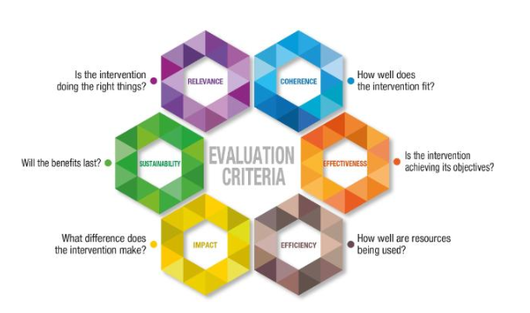CBM commissioned a feasibility study which aimed to rigorously evaluate the viability of the proposed project for "Strengthening Integration of People-Centred Ear and Hearing Care" in Zambia. This critical assessment provides essential data on opportunities, risks, and avenues for improvement in the project's conceptualization. Specifically, the study assessed the project's relevance to identified needs, scrutinized its logical framework, and evaluated the sustainability of its outcomes. It further considered how well the project integrates with other programs and stakeholders, the feasibility of its financing proposal, and its organizational structure, including necessary phasing of activities. Importantly, the study assessed the inclusiveness of the project, particularly the involvement of persons with disabilities and their representative organizations, culminating in concrete recommendations for refinement of the project concept. The assessment was based on the OECD/DAC evaluation criteria. Quality Standards for Development Evaluation: Development Assistance Committee (DAC) of the Organization for Economic Co-operation and Development (OECD):

Figure 1: Feasibility Assessment Criteria

The feasibility study successfully ascertained the relevance, coherence, efficiency, significance (impact), and sustainability aspects of the proposed project. The specific objectives of the feasibility study therefore included:

1. To assess the **relevance** of the proposed project and its activities to address the problems identified in the target groups and target sectors,
2. Coherence – To determine how well proposed intervention fit (**coherence**)
3. To ascertain which project approach can best achieve the objectives (**Effectiveness**)
4. To determine whether the planned use of funds appear economical in terms of achieving the objectives (**Efficiency**)
5. To ascertain the extent to which the planned project will contribute to the achievement of overarching developmental impacts (**Impact/significance**)
6. To determine the extent which the positive effects (without further external funding) will continue after the end of the project (**Sustainability**)

## 2.2 Methodology

### 2.2.1 Feasibility Study Design

The feasibility study was formative in nature and applied a mixed method approach that incorporated mainly qualitative and some quantitative data collection and analysis tools to ensure triangulation and credibility of findings and conclusions. This design allowed for a comprehensive assessment of the planned "Strengthening Integration of People-Centered Ear and Hearing Care in Zambia" project, considering multiple dimensions and perspectives. The main evaluation criteria included relevance, coherence, effectiveness, efficiency, significance/impact, and sustainability as outlined above (See Appendix 1 for the feasibility study process).

* **Desk review (secondary data analysis):** was conducted to provide a comprehensive overview of the planned initiative’s design, implementation, and expected outcomes. See appendix 2 for a list of reviewed documents.
* **Qualitative Research Methods:** Qualitative research methods included In-Depth Interviews (IDIs), Focus Group Discussions (FGDs), and observations, to gain in-depth insights into the social, cultural, and contextual factors influencing the ear and hearing care landscape in Zambia. These methods facilitated a deeper understanding of the needs and challenges faced by the target population, as well as the acceptability and appropriateness of the proposed interventions.
* **Quantitative Research Methods:** Health information on the prevalence of hearing loss, access to ear and hearing care services, and other key indicators were be gathered through reports from respective Provincial Health Offices. These methods provided measurable data to ascertain the anticipated effectiveness and efficiency of the planned project's interventions. These data will also inform formulation of indicators and target setting.
* **Child Safeguarding:** Throughout the feasibility study, child safeguarding was a paramount consideration. Ethical measures were implemented to protect the rights and well-being of children involved in the study. The consultant adhered to ethical guidelines and ensured that children's participation in the research was voluntary and informed, with appropriate parental or guardian consent obtained.
* **Gender Equity and Equality**: The feasibility study was guided by principles of gender equality and equity in alignment with the Evaluation Quality Assurance System Technical Note on Gender and United Nations Evaluation Group (UNEG) guidelines. Gender equality and equity-related questions and indicators were included in the feasibility assessment matrix and in data collection tools.

### 2.2.3 Feasibility Criteria

The feasibility assessment criteria for the planned project on Strengthening Integration of People-Centered Ear and Hearing Care in Zambia include several key dimensions based on the OECD/DAC evaluation criteria - Quality Standards for Development Evaluation: Development Assistance Committee (DAC) of the Organization for Economic Co-operation and Development (OECD). First, the assessment evaluated the relevance of the planned project, considering whether it will address a crucial developmental problem and align with the needs of the target groups. Coherence was then examined to determine how well the project activities aligned with human rights principles, conventions, and standards, as well as its synergy with other interventions and avoidance of duplication. Effectiveness was also assessed with the aim of ascertaining the plausibility of the planned project’s impact matrix, methodological appropriateness, and the choice of indicators. Efficiency gauged whether there would be economical use of planned funds and resources. Impact criteria scrutinized the project's anticipated contribution to overarching developmental impacts, structural changes, and the levels at which norms or structures would be affected. Sustainability focused on ascertaining the longevity of anticipated positive effects after project completion, building long-term capacities, and mitigating risks. Recommendations cover missing or overly ambitious components, potential negative effects, strengthening the cause-effect chain, and improving the impact matrix's clarity (See Appendix 3 for the detailed feasibility assessment criteria).

### 2.2.4 Sample Size Estimation

The consultant utilized a multistage cluster sampling approach. The sampling procedure involved three stages. In the first stage, all intervention provinces were selected as clusters. These provinces represented the primary units of analysis. In the second stage, seven intervention districts were randomly selected, with one district chosen from each province. This ensured representation across the intervention provinces. In the third stage, two sites were randomly selected per district, considering the inclusion of rural and urban sites. The aim was to capture a diverse range of community characteristics within the selected districts. The qualitative data sample size estimation was based on saturation. It was anticipated that saturation would be reached within interaction with 296 participants: 35 policy makers/planners/administrators, 98 direct service providers, 74 people living with hearing problems, 68 caretakers of people with ear problems, and 21 community leaders.

### 2.2.5 Study participants

The study engaged a varied group of participants, each offering unique perspectives essential for ascertaining the feasibility of the planned project:

1. **Policy Makers, Planners, Administrators**: The study included 35 participants from the Ministry of Health, Ministry of Education, and Ministry of Community Development and Social Services, representing national, provincial, district, and facility levels. These individuals, with a minimum of six months of experience in relevant policy or administrative roles and knowledge about ear health, were essential for providing insights into the policy and administrative challenges of implementing ear and hearing care programs.
2. **Direct Service Providers**: A total of 98 service providers from the Ministry of Health, Ministry of Education, and the Department of Social Welfare were part of the study. Their inclusion was based on their direct involvement in service delivery and their firsthand experiences with the challenges and practical aspects of providing ear and hearing care.
3. **People with Hearing Problems and their Caretakers**: The study included 74 individuals with hearing problems and 68 caretakers of those with ear health issues. All participants had resided in the province for over a year. This group, encompassing both those directly affected and their caretakers, offered vital insights into the personal experiences, daily challenges, and care needs related to ear and hearing health, shaping the understanding of beneficiary experiences.
4. **Community Leaders**: Our study encompassed 21 community leaders, comprising 14 members from Ward Development Committees and 7 Ward Councillors. The rationale for including current Ward Councillors and WDC members was to leverage their understanding of local community dynamics in relation to ear and hearing care.

# 3.0 Context analysis

## 3.1 Overview of Ear and Hearing Problem

The 2022-2026 National Health Strategic Plan (NHSP) of Zambia has identified ear health as a significant public health concern, emphasizing the need for strategic improvements in ear and hearing healthcare across the country. Zambia faces pronounced deficiencies in this area, including a severe shortage of specialized healthcare professionals, inadequate infrastructure, and a critical lack of necessary medical equipment in hospitals. These shortcomings present major barriers to effective care for ear and hearing problems. In terms of epidemiology, at least 5.5% of Zambia's population suffers from significant hearing loss that requires intervention. The WHO highlights that 60% of hearing loss causes are preventable or reversible. Zambia's high HIV/TB co-infection rates contribute to this issue, as the side effects of second- and third-line TB treatment drugs can cause treatment-induced hearing damage. The country also only has six qualified ENT surgeons and one audiologist, far below the WHO recommendation of 34 ENT surgeons. Additionally, there are only three functional ENT/audiology units with comprehensive equipment, and ENT drugs and consumables are not on the essential drug list. Public hospitals also lack accessibility to assistive hearing devices.

Healthcare service provision is uneven across the target provinces. Overall, there are 12 health facilities providing ENT services at the hospital level—three primary and nine secondary. Additionally, 116 primary health facilities offer ENT services. In the Central province, there are 87 health facilities with ENT services, including one secondary and no tertiary facilities. The Southern province has 33 facilities—30 primary, two secondary, and one tertiary. Lusaka province features two tertiary facilities, with no primary or secondary facilities. Eastern, Luapula, and Northern provinces lack health facilities offering ENT services, though Muchinga has an ENT department at Chinsali General Hospital. Notably, some equipment remains unused due to a shortage of specialized personnel.

Human resource capacity is also a significant issue. Central province has 126 ENT-trained healthcare workers, Southern province has 53, and Lusaka province has 27. Of these, seven are ENT surgeons, six in Lusaka and one in Copperbelt province, leaving other provinces without any ENT surgeon.

The demographic groups affected by hearing loss in Zambia are diverse, including children, adults, and the elderly from various backgrounds. Hearing loss leads to challenges in communication, social engagement, and overall quality of life. It has broad implications, causing communication barriers, social isolation, and reduced participation in community activities. Nationally, it poses a public health challenge, necessitating comprehensive policies and healthcare systems to address it. Economically, hearing loss affects individuals' ability to contribute meaningfully to regional development due to increased costs and diminished quality of life.

A more detailed context analysis is found in Annex 1.

## 3.2 Stakeholder Analysis

1. **Individuals with Hearing Impairments**: Central to the initiative, they advocate for their needs, participate in program design, and provide feedback on intervention effectiveness. Their main interest is in accessing high-quality, tailored ear and hearing care services to enhance their quality of life.
2. **Organizations for Persons with Disabilities (OPDs)**: These groups champion the rights and well-being of individuals with hearing loss, focusing on empowerment and inclusive healthcare access. They significantly influence the project's design to align with disability-inclusive principles.
3. **Ministry of Health Coordinating Committee**: Responsible for aligning the project with national healthcare systems and policies, this committeeis interested in improving healthcare accessibility and ensuring compliance with national standards.
4. **Implementing Partners (e.g., Beit Cure)**: They execute project activities, manage progress, and ensure objectives are met. Their interests include effective project management and the successful delivery of services.
5. **Government Authorities**: Key in shaping healthcare policies and resource allocation, their involvement supports the project's success. They are interested in fostering collaboration and prioritizing hearing loss issues within the healthcare system.
6. **Regional and National Healthcare Authorities**: Overseeing healthcare delivery, they focus on enhancing the system's capacity, streamlining information systems, and improving patient outcomes.
7. **Local Health Facilities and Schools**: As service providers, they contribute to the community's health and align their services with the project's objectives.
8. **Department of Social Welfare (MCDSS)**: Crucial for supporting vulnerable groups, including persons with disabilities, they provide social protection and facilitate access to essential services.
9. **Civic and Traditional Leaders**: Their roles include advocacy, community mobilization, cultural mediation, liaison, monitoring, and ensuring the sustainability of project outcomes. They are vital for raising awareness, engaging communities, and integrating local customs into project strategies.

## 3.3 Needs Assessment

The needs assessment highlights a significant demand for focused intervention in ear and hearing care. Hearing loss affects a broad demographic, including children and adults, and extends its impact to families and healthcare systems. The assessment underlines the lack of competing interventions, suggesting the proposed project could significantly impact this unaddressed need.

Regarding specific needs:

* **By Type of Hearing Impairment**: Different types of hearing loss (conductive, sensorineural, mixed, age-related, noise-induced) require varied approaches, from medical interventions to educational and preventive measures.
* **By Region**: Needs vary between rural and urban areas. Rural regions lack specialized facilities and access, while urban areas face resource constraints despite better infrastructure.
* **By Gender**: Men and boys often face occupational hazards and societal barriers, while women and girls encounter socio-cultural and economic barriers to accessing care.
* **By Age Group**: Tailored interventions for different age groups (infants and young children, school-aged children and adolescents, adults, elderly) are essential to address the specific challenges and needs of each group effectively.

## 3.4 Current Infrastructure and Resources

* **Urban vs. Rural Infrastructure**: Urban areas have better-established healthcare facilities, but specialized ear and hearing care is underdeveloped. Rural areas suffer from limited accessibility, requiring long journeys for care.
* **Shortage of Specialized Professionals**: There's a marked scarcity of audiologists and ear specialists.
* **Infrastructure Breakdown**: Only Central, Lusaka, and Southern provinces have dedicated ENT infrastructure, but lack comprehensive facilities like wards, endoscopy rooms, and treatment rooms.
* **Human Resources**: Central and Southern provinces have trained healthcare workers in primary care but lack ENT surgeons or speech therapists. Other regions are more deficient in these resources.
* **Technological and Financial Resources**: Urban hospitals are better equipped, while rural centers lack modern diagnostic equipment. Financial constraints limit the allocation of resources to ear and hearing care.

## 3.5 Policy and Legal Framework

* **Constitutional and Legal Protections**: Zambia's Constitution and the Persons with Disabilities Act provide protections and equal opportunities for persons with disabilities, including those with hearing impairments.
* **International Conventions**: Zambia is a signatory to the UN Convention on the Rights of Persons with Disabilities, committing to global standards for disability rights.
* **National Policies and Plans**: These aim to integrate disability issues into national development, focusing on accessibility and comprehensive services.

## 3.6 Risk Analysis

The identified risks include:

1. **Transportation Challenges**: Limited access to remote areas due to transportation issues for outreach programs. To counter this, reliable transportation and innovative delivery methods are needed.
2. **Healthcare Workforce Shortages and Turnover**: Inadequate healthcare staff and high turnover rates could disrupt service continuity. Strategies for workforce development and staff retention are essential.
3. **Supply Chain Disruptions**: Risks of disruptions affecting the availability of necessary devices and materials for rehabilitation. Robust supply chain management and contingency plans are required.
4. **Retention of Trained Professionals**: Professionals seeking better opportunities abroad exacerbate the shortage. Measures to incentivize professionals to stay in Zambia, such as competitive compensation and career development, are needed.
5. **Community Resistance or Apathy**: Local community resistance or apathy towards awareness programs. Employing culturally sensitive and community-driven approaches is necessary.
6. **Inadequate Communication for Awareness Campaigns**: Lack of effective communication channels and media support. Partnerships with local media are important for effective communication.
7. **Misinformation and Myths**: Persistence of misinformation and myths about ear and hearing care in the community. Awareness campaigns should aim to dispel these myths and provide accurate information.
8. **Cultural Beliefs and Discrimination**: Deep-rooted cultural beliefs and attitudes lead to discrimination against individuals with hearing loss. Culturally sensitive awareness initiatives and community dialogues are required.
9. **Lack of Legal Protections**: Absence of legal protections and policies against discrimination. Collaboration with legal experts and advocacy for legal protections are needed.
10. **Resistance to Inclusivity Initiatives**: Local communities' resistance or hostility towards inclusivity initiatives. Extensive community consultations and involvement of local leaders are crucial.
11. **Stakeholder Apathy or Resistance**: Apathy or resistance from stakeholders in engaging with ear and hearing care issues. Active collaboration and capacity-building programs for stakeholders are necessary.
12. **Media Outlet Awareness**: Lack of understanding and minimal coverage of ear and hearing care topics by media outlets. Training and sensitization programs for media outlets are needed.

**3.7 Cultural and Social Considerations**

1. **Stigma Surrounding Hearing Impairments**: The study highlights the stigma and fear of social isolation that leads individuals to conceal hearing issues. Addressing the social and emotional dimensions of hearing care is as important as the medical aspects.
2. **Influence of Cultural Beliefs**: In rural areas, traditional healers are often the first point of contact for hearing issues, delaying access to medical interventions. Bridging the gap between traditional practices and modern healthcare is essential.
3. **Language Diversity**: With a multitude of indigenous languages, providing care in multiple local languages is crucial to overcome language barriers, especially in remote areas.
4. **Gender Dynamics**: The roles of men and women in society affect healthcare decision-making. Strategies promoting gender equity in ear and hearing care services are necessary.
5. **Community Structures and Decision-Making**: The collective decision-making prevalent in close-knit communities greatly influences healthcare access. Community participation in planning and implementation is key.
6. **Geographical Challenges**: Mobile clinics are recommended to provide services in remote and underserved areas, ensuring broader healthcare accessibility.
7. **Training Local Healthcare Workers**: Equipping local healthcare workers with the necessary skills for basic ear and hearing care services improves accessibility, particularly in underserved areas.
8. **Inclusivity in Planning and Implementation**: Involving persons with disabilities actively in the planning and implementation processes ensures a more inclusive approach and community acceptance.



# 4.0 Relevance Assessment

This section presents key findings of a rigorous analysis of the project's alignment with the urgent developmental needs and extant healthcare priorities within the targeted regions, with an intensified focus on the domain of ear and hearing care. This comprehensive assessment is instrumental in affirming the project's foundational rationale, underscoring its indispensability, pertinence, and strategic congruence within the wider developmental and healthcare paradigms.

|  |
| --- |
| **Key Relevance Assessment Question**   * To what extent is the planned project likely to do the right thing? |

## 4.1 Identified bottlenecks

The planned project is positioned against a backdrop of compelling global and regional health imperatives The World Health Organization underscores a daunting reality: more than 5% of the global population, translating to approximately 430 million individuals, grapples with disabling hearing loss. This demographic is projected to witness a significant escalation, reaching over 700 million by 2050. It is pertinent to note that a disproportionate 80% of these cases reside in low- and middle-income countries, presenting a clarion call for concerted, strategic intervention in these regions. In this vein, the project is meticulously designed to address critical developmental bottlenecks and systemic challenges inherent in the current health infrastructure of Zambia, focusing specifically on ear and hearing care. The identified areas of intervention, delineated below, emerge from a comprehensive analysis of the prevailing gaps, resource constraints, and the health-seeking comportment of the targeted communities.

**Limited access to services**: Across the target provinces, limited access to ear health and rehabilitative services is a pressing issue, with stark disparities in service availability and quality. Luapula, Northern, and Eastern Provinces are particularly characterized as service deserts with a lack of formalized ear and hearing care. In contrast, Central, Muchinga, Lusaka, and Southern Provinces, despite some existing services, face significant limitations due to a shortage of specialists, inadequate infrastructure, and essential diagnostic and treatment equipment like audiometers, otoscopes, and hearing aids. This gap is more pronounced in rural areas, exacerbating economic strain and leading to adverse social and health outcomes, such as impaired communication abilities and reduced life quality. Key challenges include insufficient training and capacity building for healthcare workers in ear health, leading to underdiagnosis and undertreatment, financial and geographic barriers, especially in remote areas, and societal issues like stigma and low awareness about ear health. Intermittent external support also results in a lack of continuity in services. In Muchinga, for instance, the general hospital has standard equipment but lacks the manpower to operate it, leaving the ENT department non-functional. Rehabilitation services, including assistive listening devices, auditory training, and speech therapy, are particularly scarce in targeted sites, with a notable concentration in urban centers like Lusaka, Kabwe, and Livingstone, leaving rural areas underserved and forcing individuals with hearing impairments to travel long distances for essential services.

*"As a district, we have some equipment at the General Hospital that are up to the standard, but there's no manpower. There's no one to use them. So, the ENT department is there with equipment, but it's not open because of lack of human resource."* (**KII, Muchinga**).

***“I****n most of the times, we are not being attended to when we go to hospitals because there is no communication at all… If I am sick and go to the hospital, the nurses will just look at me because they do not understand anything on what I am saying…”* **(FGD, Potential Beneficiaries)**

**Limited public awareness and education**: The study revealed a notable trend concerning public awareness and education about ear health across the target regions. It was observed that limited awareness of ear health issues was a common challenge in most study sites. However, a contrasting improvement was evident in Lusaka, indicating a positive shift in public health education and awareness efforts in this urban locale. In many of the study sites, the general population exhibited a lack of understanding regarding the importance of ear health, the early signs of hearing problems, and the preventive measures necessary to avoid common ear ailments. This limited awareness often resulted in delayed diagnosis, a prevalence of misconceptions surrounding ear health, and a lack of engagement with preventive practices. Contrastingly, in Lusaka, study participants reported a significant improvement in public awareness about ear health. This improvement was attributed to increased accessibility to ear health information, and more robust community engagement initiatives in the urban setting. These efforts in Lusaka have contributed to better knowledge about the importance of ear health, a reduction in stigma associated with hearing impairments, and an increase in the adoption of preventive measures. The planned project is relevant as it seeks to mitigate delayed treatment seeking behaviors and lost opportunities for early interventions, thereby promoting a proactive healthcare-seeking culture.

**Capacity Constraints among OPDs**: Organizations of People with Disabilities reported having capacity constraints that limit their ability to effectively advocate for and support their members experiencing ear problems across the study sites. The common constraints included limited financial resources, insufficient staffing, and a limited access to necessary technology and infrastructure for ear health. Additionally, OPDs may struggle with obtaining the necessary expertise or training to effectively lobby for policy changes, provide educational programs, or offer support services. They further report that this lack of capacity often hinders their ability to influence decision-making processes and effectively represent the interests of people with ear and hearing problems.

**Social Isolation, Stigma, and Discrimination**: The FGDs with people living with hearing problems revealed that they often face social isolation, stigma, and discrimination. The analysis indicated that the isolation often stems from a lack of accessible communication, which hinders their ability to participate fully in community and social activities. Stigma and discrimination manifest in various ways, from overt prejudice to more subtle forms of exclusion or patronizing attitudes. These societal challenges lead to reduced self-esteem, decreased opportunities for education and employment, and an overall diminished quality of life. The lack of understanding and awareness among the general public about the challenges faced by people with hearing impairments contributes significantly to these issues. As a result, many individuals with hearing problems report that they find themselves excluded from mainstream society, which further perpetuates their isolation.

**Limited Research on Ear Health**: There is a notable deficiency in research focusing on ear health, particularly in areas such as the prevalence and causes of hearing impairments, effective treatment options, and the societal impact of hearing loss. This lack of research contributes to gaps in knowledge that are essential for developing effective health policies and interventions. Without robust data and analysis, it becomes challenging to advocate for necessary resources, design appropriate services, and implement preventive measures. The limited research also affects the development of new technologies and therapies that could benefit individuals with hearing impairments. Increasing research in this field is crucial not only for enhancing our understanding of ear health issues but also for informing policymakers, healthcare providers, and the broader public about effective strategies for addressing ear and hearing problems.

**Policy and Funding Gaps**: The information from policy makers, planners and administrators indicate that the area of ear and hearing care suffers from significant policy and funding gaps. These gaps can be attributed to a lack of prioritization within health and social policies, leading to inadequate resource allocation for the necessary services, research, and infrastructure. The absence of comprehensive policies that specifically address the needs of individuals with hearing impairments means that their requirements are often overlooked or inadequately met. Furthermore, the funding allocated for disability services and rehabilitation is frequently insufficient, limiting the availability and quality of services. This shortfall in policy and funding not only impacts the availability of medical and support services but also affects public health initiatives and educational programs aimed at preventing hearing loss.

**Socioeconomic implications**: The assessment brings to light the socioeconomic implications of hearing loss. Individuals with hearing impairments face substantial barriers in accessing social services, employment, and financial assistance, such as loans. These challenges are compounded by communication hurdles, potential stigma, and discrimination, particularly within institutions like banks. The perception of individuals with hearing loss as less capable creates an additional layer of disadvantage, marginalizing them from mainstream opportunities and social services. The systemic challenges extend beyond health implications, affecting the social inclusion and economic participation of individuals with hearing impairments. This multifaceted impact establishes the problem of ear and hearing health as a major concern that transcends the medical realm, warranting a comprehensive intervention strategy. The intervention must encompass health, educational, and socioeconomic dimensions to address the needs of those affected holistically, ensuring their full participation in society. This holistic approach is not only a health necessity but also a mandate for social justice and equity.

## 4.2 Alignment of the project initiatives with identified bottlenecks

The planned project is strategically designed to address the identified bottlenecks in ear and hearing care, as highlighted in the comprehensive analysis of the prevailing gaps and challenges. Here's how the project initiatives align with each identified bottleneck:

|  |  |
| --- | --- |
|  |  |
| ! | **Limited access to services**: The project aims to bridge the significant gap in access to ear and hearing care services, especially in resource-scarce regions. By addressing this absence of formalized services, the initiative intends to alleviate the economic strain on these populations and improve their overall social and health outcomes. The focus is on enhancing service availability and quality, even in underserved regions like Luapula, Northern, and Eastern Provinces, thereby reducing the disparities currently seen across different provinces. |
|  |  |
| ! | **Limited access to Rehabilitation Services**: Recognizing the scarcity of comprehensive rehabilitation services, the planned project emphasizes providing rehabilitation services. The initiative is particularly focused on expanding these services beyond urban centers like Lusaka to reach underserved regions, ensuring equitable access to essential rehabilitation services for individuals with hearing impairments. |
|  |  |
| ! | **Shortage of trained professionals:** To tackle the critical shortage of specialized healthcare professionals, the project will implement strategies for training and capacity building. This approach is vital for ensuring early identification and effective management of hearing impairments, thereby strengthening the overall responsiveness of the healthcare system to hearing care needs. |
|  |  |
| ! | **Limited public awareness and education**: The project aims to enhance public awareness and education about ear health. By addressing the widespread lack of awareness, it intends to encourage early intervention and promote a culture of proactive healthcare-seeking, thus mitigating the issues arising from delayed treatment seeking behaviors. |
|  |  |
| ! | **Social isolation, stigma, and discrimination**: Adopting a transformative approach, the project seeks to counter the societal stigma associated with hearing loss. Strategic community engagements and public awareness campaigns are planned to enhance societal inclusivity and boost the self-esteem of individuals with hearing impairments. |
|  |  |
| ! | **Policy and funding gaps**: The planned project is aligned with the need for more agile policy formulation and resource allocation. It emphasizes the importance of building government capacity to elevate people-centered ear and hearing care on the national agenda, addressing the significant policy and funding gaps currently present. |
|  |  |
| ! | **Capacity constraints among stakeholders**: Identifying the capacity vacuum within OPDs and other key stakeholders, the project includes targeted strategies to strengthen their advocacy and operational effectiveness. Enhancing the capacity of these organizations is crucial for representing the interests of people with ear and hearing problems effectively. |
|  |  |
| ! | **Lack of research**: The initiative stresses the importance of evidence-based practices and advocates for robust research mechanisms. Such research is essential for understanding the true burden of hearing impairments and for informing effective healthcare strategies and funding priorities. |
|  |  |

## 4.3 Compatibility of norms and standards of the approach with target group’ needs

The planned project's approach to ear and hearing care is highly compatible with the needs of its target groups, embodying a blend of inclusivity, quality, community engagement, and evidence-based practices. Activities like training healthcare workers, enhancing facility equipment, and conducting community outreach are aimed at making services more accessible, especially in underserved areas, aligning with international health equity norms. Emphasizing local capacity building and involving international standards, the project ensures high-quality care. The participatory strategy, involving people with hearing loss, community volunteers, and OPDs, adheres to sustainable development norms, while the use of WHO protocols and local data collection underpins its evidence-based methodology. This comprehensive approach ensures that the project not only meets the specific needs of its target groups but also aligns with global best practices in health care.

## 4.4 Conflict-Sensitive Design (Do-No-Harm Principle)

The project is carefully designed with a conflict-sensitive approach, adhering to the Do-No-Harm principle. It incorporates cultural sensitivity by engaging with local customs and leadership, reducing the risk of community conflict. The focus on capacity building, particularly through training local health workers, aims to reduce dependency on external aid and empower communities, aligning with the Do-No-Harm approach by preventing tensions related to resource allocation. Inclusivity and equity are central, ensuring that interventions do not marginalize any group, thus avoiding potential conflicts. Adherence to data privacy and ethical standards, implied through collaboration with international entities, ensures respect for individual and community rights. Additionally, the implementation of community feedback mechanisms highlights the project’s commitment to adaptability and responsiveness, key to maintaining harmony and preventing escalation of grievances. This comprehensive, considerate approach reflects the project's dedication to a conflict-sensitive and ethically sound implementation.

**Summary of relevance assessment outcomes:** The Relevance Assessment of the project underscores its critical alignment with the urgent ear and hearing needs in the targeted regions. Addressing identified bottlenecks like limited-service access, particularly in provinces like Luapula, Northern, and Eastern, the project plans to bridge service gaps, enhance public awareness, and tackle the shortage of trained professionals. Furthermore, it aims to counteract issues of social isolation, stigma, and discrimination through inclusive and transformative strategies. Recognizing policy and funding gaps, as well as capacity constraints among stakeholders, the project is set to bolster government capacity and strengthen advocacy and operational effectiveness. Its compatibility with target group needs is evident in its inclusivity, quality focus, community engagement, and adherence to international health equity norms. Additionally, the project’s conflict-sensitive design, based on the Do-No-Harm principle, emphasizes cultural sensitivity, capacity building, data privacy, and ethical standards, ensuring a respectful and sustainable approach to addressing the multifaceted challenges of ear and hearing health in these communities.

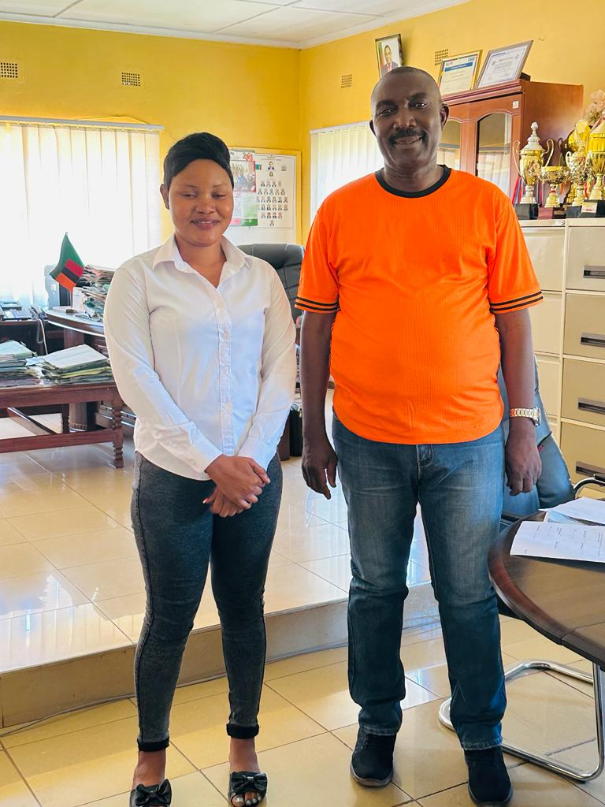

# 5.0 Coherence Assessment

In this coherence assessment, we evaluate the project's integration and alignment with established human rights principles, standards, and existing health initiatives. The analysis hinges on the project's adherence to inclusion and participation criteria, its synergistic alignment with ongoing interventions by entities like Beit Cure and the Ministry of Health, and its capacity to foster value addition while avoiding redundancy. This examination not only underscores the project's contextual relevance but also its potential for creating a unified, effective approach within the broader health ecosystem.

|  |
| --- |
| **Key Coherence Assessment Question**   * How well does the project fit? |

## 5.1 Coherence of planned activities with human rights principles

The project's design exhibits a profound coherence with human rights principles, particularly those of inclusion and participation, which are evident in its strategies to improve the lives of individuals with, or at risk of, hearing loss. This alignment is not incidental but is woven into the fabric of the project’s objectives and expected outcomes, promising a significant impact on this vulnerable population. Firstly, the capacity-building component is comprehensive, aiming at a systemic change within ear and hearing care. The emphasis on training a spectrum of healthcare professionals and community advocates, as detailed in Result 1, is a testament to the project's commitment to creating an inclusive healthcare environment. By bolstering professional expertise, from nurses and clinical officers to ear and hearing care specialists, the project is set to enhance the quality and accessibility of care. This is further augmented by community-level interventions, where the training of volunteers is expected to bridge gaps in knowledge and services at the grassroots level. This approach doesn’t just align with human rights principles; it brings them to life in community settings, ensuring that rights and dignity form the cornerstone of practical everyday healthcare.

In addition to direct healthcare impacts, the project recognizes the role of advocacy and community engagement in shaping a more inclusive society. The activities under Result 2 reflect a deeper understanding of societal barriers faced by individuals with hearing disabilities. Awareness campaigns, engagement with policy makers, and the empowerment of Persons with Disabilities (PwD) indicate a multi-layered strategy to tackle stigma, misinformation, and policy shortfalls. By enabling PwD and their communities to take an active role in these initiatives, the project supports the fundamental human rights principles of participation and active agency in societal matters.

Result 3 introduces a critical dimension: sustainability and evidence-based practice. The activities under this result show a clear intention to ground the project in solid research and data, adhering to global standards and guidelines. The integration of WHO protocols and the emphasis on local data collection and analysis for policy influencing underscores the project's commitment to sustainable, long-term change. Moreover, it ensures that the project does not operate in isolation but is a part of a larger ecosystem of healthcare provision, informed by real-world evidence and best practices. Lastly, the project exhibits a strategic understanding of the importance of synergy and value addition in the health sector. It actively seeks to create linkages with other interventions and actors, such as the Ministry of Health and various organizations working with PwD. This approach not only avoids duplication of efforts but also ensures that resources are maximized and that different initiatives complement each other.

## 5.2 Alignment with local and international guidelines/provisions

**Alignment with WHO guidelines on Ear Health Care (EHC):** The World Health Organization (WHO) has established guidelines for the management of ear, nose, and throat (ENT) conditions, focusing on building the capacity of health workforces to provide ear and hearing care at the community level. These guidelines are encapsulated in the WHO's Primary Ear and Hearing Care Training Manual, which serves as a practical guide on the prevention, identification, and management of hearing loss and common ear diseases. This manual is designed for training health workers and doctors at community-level primary healthcare facilities and includes modules on the mechanism of hearing, ear examination, hearing assessment, and the rehabilitation of hearing loss. The WHO emphasizes the integration of ear and hearing care within primary care as a critical component of universal health coverage. However, there is a global shortage of highly trained ear and hearing care professionals, particularly in low- and middle-income countries, which typically have less than one ENT specialist and one audiologist per million population. To address this, WHO advocates for the reorientation of care models to integrate services at the primary level and calls for systematic training of healthcare providers, including doctors, nurses, and community health workers, in ear and hearing care.

The planned project's objectives, strategies, and activities demonstrate a strong alignment with WHO guidelines, particularly in enhancing workforce capacity at the community level, integrating EHC into primary healthcare, and addressing the shortage of trained professionals in this field as shown below:

1. **Training Health Workers in EHC**: The project targets training 410 healthcare professionals in audiology and 60 teachers in identifying hearing loss in children. This directly corresponds to the WHO’s emphasis on training health workers and doctors at community-level primary healthcare facilities, as outlined in the WHO's Primary EHC Training Manual.
2. **Focus on Primary Care Integration**: The WHO advocates for the integration of ear and hearing care within primary healthcare as a part of universal health coverage. This project’s objective to strengthen ear and hearing care and make it part of the national health plan aligns with this guideline, focusing on integrating these services at a primary level.
3. **Addressing the Shortage of Specialized Professionals**: Recognizing the global shortage of ear and hearing care professionals, especially in low- and middle-income countries, the project's initiative to train a substantial number of professionals in Zambia is in direct response to this need, following WHO’s call for increasing the number of trained professionals in this field.
4. **Reorientation of Care Models**: The WHO calls for a reorientation of care models to integrate services at the primary level. This project’s multifaceted approach, including community outreach, training of non-specialists, and enhancing the capabilities of existing health facilities, aligns with this recommendation.
5. **Systematic Training for Diverse Healthcare Providers**: WHO emphasizes the need for systematic training of a range of healthcare providers in ear and hearing care. The project’s activities, such as training nurses, clinical officers, and community health volunteers, align with this WHO guideline, expanding the base of trained personnel in EHC.
6. **Community-Level Focus and Universal Health Coverage**: The project’s aim to reach a population of 4.2 million people across urban and rural areas of Zambia with improved ear and hearing care services mirrors the WHO’s emphasis on community-level interventions and universal health coverage in ear and hearing care.

**Alignment with Sustainable Development Goals (SDGs):** The "Strengthening Integration of People-Centred Ear and Hearing Care in Zambia" project aligns significantly with the United Nations Sustainable Development Goals (SDGs), particularly SDG 3, which focuses on ensuring good health and well-being. By improving the quality and accessibility of ear and hearing care, the project directly contributes to enhancing overall health outcomes, a core objective of SDG 3. It also supports SDG 4, which emphasizes quality education, by training teachers to identify and assist schoolchildren with hearing impairments, thus fostering inclusive learning environments. Furthermore, the project addresses SDG 10's aim of reducing inequalities by focusing on a marginalized group, people with hearing impairments, ensuring they receive equitable healthcare services. The collaborative nature of the project, involving various stakeholders, also resonates with SDG 17, which advocates for partnerships to achieve these goals, illustrating the project's comprehensive alignment with the SDGs.

**Alignment with the Zambia National Health Strategic Plan (2022-2026):** The project is supportive of the Zambia National Health Strategic Plan through its comprehensive approach to enhancing ear and hearing care. By focusing on strengthening the capacity of healthcare workers, including training in audiology and primary ear and hearing care, the project enhances the quality and accessibility of healthcare services. This initiative aligns with the strategic plan’s objectives of bolstering healthcare systems at both primary and secondary levels, aiming to provide more equitable and quality healthcare services to the Zambian population. Additionally, integrating these specialized care services into the national health framework mirrors the strategic plan’s focus on holistic health service improvement and accessibility, making a significant contribution to Zambia's overarching health goals.

**Alignment with the Zambia ENT Strategic Plan (2017-2021):** The planned project closely aligns with Zambia's National Ear Nose and Throat (ENT) Strategic Plan (2017 - 2021). Key areas of alignment include enhancing ENT services, especially in underserved regions, through the training of 410 healthcare workers and 60 teachers in audiology and hearing care. This focus on capacity building and training directly supports the strategic plan's emphasis on strengthening the workforce for effective ENT care. Additionally, the project's commitment to community outreach and engagement, including school screenings and public awareness campaigns, resonates with the plan's objective of enhancing community involvement in ENT health. The integration of ear and hearing care into the national health plan aligns with the strategic plan’s goal of incorporating ENT services into Zambia’s broader healthcare system. The project also addresses the plan's focus on research and data collection by conducting studies on ear conditions and hearing loss, contributing valuable insights for policy and healthcare decision-making. Overall, the project’s initiatives in training, community engagement, integration into health systems, and research demonstrate strong support for the objectives and priorities of Zambia's National ENT Strategic Plan.

## 5.3 Synergies and linkages between the planned project and other interventions

In all the target regions, Ministry of Health and Ministry of Education have stablished structures including Provincial and District Offices, schools and health facilities, as well as resources centres. For health facilities, there also exists Neighbourhood Health Committees with hundreds of Community Health Workers and volunteers who contribute to the efforts of each community health facility. The planned project is designed to intertwine with the existing frameworks of the Ministries of Health and Education, supplementing governmental efforts in a synergistic collaboration that amplifies the reach and efficacy of interventions aimed at individuals with, or at risk of, hearing loss. By operating within the established infrastructures of these ministries, the initiative will leverage governmental resources, particularly human capital, as it engages ministry staff across various levels. This strategy ensures the project's seamless integration into the public health and education sectors, enhancing sustainability and adherence to national standards and protocols.

Significantly, this approach underscores the project's role in capacity building among existing healthcare and educational professionals. Instead of creating parallel structures, CBM and Beit Cure strategically enhances the current system, providing specialized training for health workers and educators within their respective ministry frameworks. Activities such as the Hearing Aid Technician course, audiology qualification courses, and the training of schoolteachers directly contribute to professional development, task-shifting, and the expansion of the ministries' service portfolios. These initiatives do not only fortify the skills within the ministries but also ensure that the care delivered is standardized, accessible, and in line with national and international best practices.

Moreover, the project's collaborative nature fosters a more holistic approach to ear and hearing care, ensuring it is not an isolated endeavour but an integral component of broader health and education programs. The inclusion of EHC services in the national health plan, to be facilitated by this project, exemplifies the synergistic efforts between CBM, Beit Cure, the Ministry of Health, and other entities, contributing to comprehensive care models. This integrated approach aids in eliminating service silos, encouraging a more coordinated response to hearing health needs across various demographic groups. Furthermore, the project’s emphasis on utilizing ministry staff signifies a profound respect for and reliance on local expertise and institutional knowledge, which is pivotal for the customization of health interventions. This methodology not only ensures that the interventions are culturally relevant and context-specific but also promotes ownership and commitment among government staff, thereby multiplying the project’s chances for success.

In essence, the planned project demonstrates the power of collaborative governance in health and education sectors. By embedding itself within the structures of key ministries, the project transcends traditional NGO-government dynamics, instead fostering a partnership that pools resources, shares expertise, and ultimately, serves the public in a more holistic, efficient, and sustainable manner. Through this initiative, CBM and Beit Cure reaffirms its commitment to strengthening Zambia's health and education systems, contributing tangibly to the nation's journey toward improved hearing health and overall well-being.

## 5.4 Extent of value addition and duplication avoidance

The project is strategically poised to add substantial value to the existing health and education ecosystems in Zambia. One salient aspect of this value addition is the project's nuanced approach to identifying gaps within current systems rather than overlaying existing services, thus avoiding unnecessary duplication. By meticulously mapping out the landscape of services provided by various stakeholders, including governmental and non-governmental entities, the initiative ensures that its activities fill unmet needs, thereby optimizing resource allocation and enhancing the overall spectrum of services available to the public.

The sentiment echoed by key informants from various ministries, including the MOE, MOH and MCDSS, emphasizes the imperative of seamlessly integrating programs addressing hearing impairment into established community and governmental frameworks. Their collective viewpoint stresses the longevity and effectiveness of interventions when harmoniously woven into existing structures. These informants underscore the importance of leveraging the strengths of already operational community services and government programs. Through such integration, resources can be optimally utilized, and initiatives can be sustained beyond the lifespan of specific projects. The collaborative efforts across ministries signal a holistic approach, acknowledging that hearing impairment interventions should not exist in isolation but be part of the broader tapestry of community and government services.

The key informants collectively emphasize that successful integration relies on partnerships, collaborations, and clear communication among stakeholders. By aligning initiatives with established structures, they contend that the impact will not only be more profound but also accepted and supported by the communities they aim to serve. One of the key informants echoed the sentiments of majority of the key informants at provincial and district levels when they said;

*"If the program will come or the project will come with its own independent structure, the danger is that when that program comes to an end, how is that structure going to be sustained? It becomes a problem. But if it's integrated into the already existing structure...then it will be very easy to sustain it."* (KII, Policy Maker).

Central to this is the project's emphasis on comprehensive capacity building and specialization in areas often underserved or overlooked within standard healthcare and educational frameworks. For instance, the focus on training programs for Hearing Aid Technicians and audiology qualifications addresses a critical skills gap, equipping the local workforce with specialized knowledge that is currently in scarce supply. These endeavours do not replicate but rather augment existing educational and professional development pathways, reinforcing the system's resilience and responsiveness to community needs.

Moreover, the project champions innovative approaches such as task-shifting and community-level engagement, which are not just beneficial but also necessary in regions where healthcare access is limited. These strategies, including training community health volunteers and schoolteachers, extend the reach of essential health services to remote or underserved areas, circumventing traditional barriers to access. By doing so, the project capitalizes on local structures and relationships, fostering community ownership and sustainable practices that are likely to outlive the project's lifespan.

In terms of research and data collection, the initiative's commitment to conducting population-based studies and other forms of evidence gathering stands out as a value-added activity. These efforts will provide a repository of localized data, insights, and learnings, contributing to a knowledge base that stakeholders within and beyond Zambia can reference. This foundation is crucial for informed policymaking, effective resource utilization, and the shaping of context-specific interventions in the future. Preventing duplication also involves active coordination and collaboration with ongoing initiatives. Beit Cure's project is designed to work in concert with national efforts and other NGO activities, seeking synergies and complementarities. Regular stakeholder meetings, collaborative platforms, and formal agreements, like Memorandums of Understanding with relevant entities, facilitate this coordination, ensuring alignment of objectives and consolidation of efforts rather than competition or redundancy.

All target regions but Northern Province has seen efforts from Healthy Learners whose approach is similar to the project in improving the health of learners. The Healthy learners’ program trains teachers, health care workers and builds health rooms in schools. They screen and treat schoolchildren within the school system and refer to health facilities for better health care. In urging the project to avoid duplication, one of the key informants from Luapula Province said

*“While the Healthy Learners organization is involved, they've identified gaps in their program's effectiveness and aim to enhance it. It's challenging to assess the new program's success as it's just started. However, they are not only focusing on children with difficulties but all individuals in a particular school, ...the new program aims to build capacity at the school and health facility levels. Engaging stakeholders is crucial for successful implementation. Existing structures and trained personnel play a key monitoring role. Avoiding duplication with Healthy Learners* [will] *involve understanding their approach and potentially adding valuable elements”* (KII, Policy Maker)

In essence, the planned project's emphasis on gap-filling, capacity building, innovative service delivery, and evidence-based practice contributes unique, lasting value to Zambia's health and educational landscapes. By conscientiously steering clear of duplicative efforts and instead seeking to bolster existing systems and resources, the initiative promises enhanced service delivery, greater accessibility, and a richer, more informed context for the ongoing improvement of ear and hearing care within the country.

**Summary of** **coherence assessment outcome:** The coherence assessment reveals the project’s strong alignment with human rights principles, standards, and existing health initiatives. It emphasizes inclusion and participation, aligning with ongoing interventions by MOH and stakeholders like Beit Cure, and aims for value addition without redundancy. The project’s design integrates human rights principles, particularly in capacity building for a wide range of healthcare professionals and community advocates. This approach enhances the quality and accessibility of care and addresses societal barriers, including stigma and misinformation. The project's alignment with WHO guidelines, particularly in enhancing workforce capacity at the community level, is evident. Its objectives and activities align with the WHO's emphasis on training health workers and integrating ear and hearing care into primary healthcare. This alignment extends to supporting the SDGs, particularly in promoting good health and well-being, inclusive education, and reducing inequalities. The project also aligns with the Zambia NHSP 2022-2026 and the Zambia ENT Strategic Plan 2017-2021, focusing on strengthening healthcare systems and incorporating ENT services into Zambia’s broader healthcare system. Additionally, the project is designed to intertwine with existing frameworks of the Ministries of Health and Education, enhancing sustainability and adherence to national standards. Its collaborative nature fosters a holistic approach, ensuring ear and hearing care is an integral component of broader health and education programs. The project adds value by identifying gaps within current systems, avoiding duplication, and augmenting existing educational and professional development pathways. It also champions innovative approaches like task-shifting and community-level engagement, extending the reach of essential health services. Furthermore, the project's commitment to conducting research and data collection contributes to a knowledge base for informed policymaking and effective resource utilization. Overall, the project's emphasis on gap-filling, capacity building, innovative service delivery, and evidence-based practice promises enhanced service delivery and greater accessibility in Zambia’s health and educational landscapes.

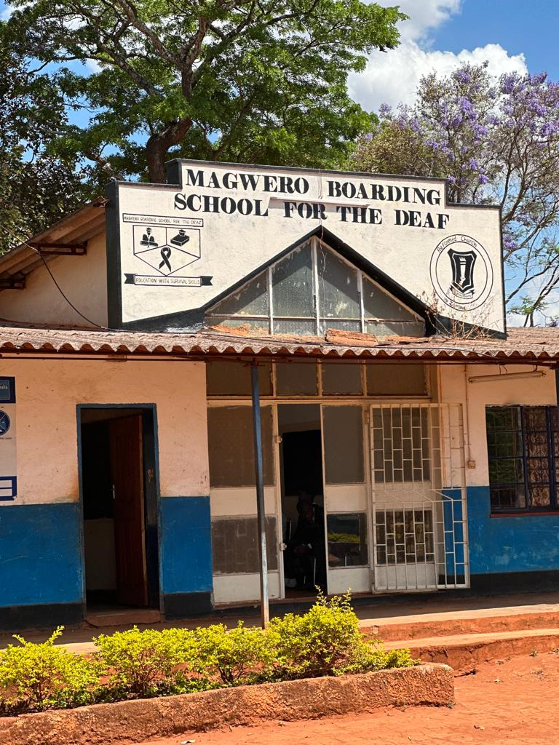

# 6.0 Effectiveness Assessment

The effectiveness section critically evaluates the project's strategic underpinnings and potential for achieving its objectives, focusing on the practicality of the theory of change, the foreseeability of any negative impacts, and the aptness of the methodological approach within the given context. This assessment will also consider the necessity for supplementary activities to enhance effectiveness, scrutinizing the adequacy of current indicators in capturing the true extent of the project's transformative impact.

|  |
| --- |
| **Key Effectiveness Assessment Question**   * Which project approach can best achieve the objectives? |

## 6.1 Plausibility of the impact theory of change

Evaluating the plausibility of the impact theory of change within this project hinged on a critical examination of the logical framework and underlying assumptions connecting the project's activities to its ultimate goal of improving the quality of life for those with, or at risk of, hearing loss. The theory is constructed on the premise that enhancing professional expertise and resources in ear and hearing care, coupled with robust advocacy and a strong evidence-based approach, will significantly contribute to a more inclusive and effective healthcare system.

This pathway seems plausible given that the project's approach is multifaceted: it addresses not only the immediate need for specialized care but also aims at the systemic integration of these services into the national health plan, ensuring sustainability. Capacity building activities, particularly the training of a range of healthcare providers and stakeholders, promise a broader base of service provision and advocacy. Furthermore, the emphasis on evidence—through activities like the population-based study and continuous data collection and monitoring—ensures that the project strategies are responsive and adaptable to the actual needs and evolving realities of the target community.

However, the theory's plausibility must also be considered in the context of potential external factors and assumptions. These include the sustained commitment of stakeholders (government bodies, health institutions, OPDs, etc.), the adaptability of national health systems to integrate and prioritize ear and hearing care, and the community's willingness to shift perceptions and behaviors regarding hearing health and disability inclusion. Additionally, the project assumes a certain level of infrastructure and resource availability, which, if not met, could impede progress. It suffice to say the theory of change is grounded in logical reasoning and a strategic approach, its plausibility ultimately depends on the successful and synergistic interaction of both the project’s internal components and external environmental factors. Continuous evaluation of these interactions is essential to assess ongoing relevance and effectiveness, making necessary adjustments to ensure the project's path remains aligned with its ambitious impact goals.

## 6.2 Potential negative effects

**Overburdening of Existing Health Systems**: Introducing new activities could strain resources in facilities with already limited capacities, potentially leading to a decline in the quality of care in other areas. Task-shifting, although efficient, might overload current staff, leading to burnout and reduced productivity.

**Inequity in Service Accessibility**: The concentration of services within project sites creates a form of health access disparity where the benefits become accessible only to individuals within these catchment areas. Consequently, those residing outside of these zones, particularly in remote or underprivileged regions, face significant barriers to accessing the specialized ear and hearing care services. This limitation not only exacerbates existing health inequities but also amplifies a sense of neglect among those communities just beyond the project's operational scope, making it imperative to strategize on resource allocation with an eye toward broader, more equitable access.

**Stigmatization**: The risk of unintended stigmatization in the project arises primarily from the possibility that concentrated attention on individuals with hearing impairments could inadvertently reinforce their perception as distinctly different or 'other.' This issue could manifest in a few ways as highlighted from the following excepts:

*“In efforts to raise awareness and provide specialized services, there is a possibility that these individuals might be continually highlighted for their hearing impairments, which could inadvertently emphasize their differences from the broader community. This constant focus might lead to a reinforced perception of them being separate or distinct, which could contribute to stigmatization* **(KII, Community Leader)**

*“The project’s specialized focus on individuals with hearing impairments might lead to unintended reactions from the broader community. For instance, well-meaning initiatives could inadvertently result in pity or patronizing attitudes from others, which can be a form of stigmatization”.* (**KII, Administrator**)

*” There's the risk that individuals with hearing impairments, feeling overly singled out due to the focused attention of the project, might choose to self-isolate to avoid being seen as different”* (**KII, Service Provider**)

**Data Privacy Concerns**: The collection and handling of medical data for monitoring, evaluation, or research purposes raise concerns about confidentiality and the ethical use of such information. Mishandling of this data could violate privacy rights and erode trust in health services.

**Unsustainable Dependency**: Certain activities within the project could inadvertently foster unsustainable dependency. For instance, service providers might become overly reliant on project incentives such as allowances, which could lead to challenges in sustaining their motivation and commitment once these incentives are withdrawn. ENT departments might become dependent on the project for essential supplies, creating a potential vacuum in resources when the project support ceases. Additionally, beneficiaries could develop a heavy reliance on the project for their needs, which could lead to difficulties in self-reliance and continuity of care post-project. Such dependencies are particularly concerning as they might lead to a significant gap in service provision and support once the project phases out and external resources are reduced or withdrawn.

## 6.3 Appropriateness and sufficiency of methodological approach

**Appropriateness to Context**: The project demonstrates cultural and socioeconomic sensitivity by employing local capacity-building strategies, such as training nurses, clinical officers, and community health volunteers, effectively aligning with a community-based approach suited for regions with limited healthcare access. Additionally, its emphasis on integrating ear and hearing care into national health plans is a strategic move towards systemic and policy-level change. This approach not only ensures the sustainability of the project's impacts but also extends its reach beyond its immediate scope, fostering a more inclusive and comprehensive healthcare system that addresses ear and hearing care as a core component of national health priorities.

**Sufficiency for Achieving Project Objectives**: The project's comprehensive capacity-building initiatives encompass training programs for a diverse range of stakeholders, from healthcare workers to media personnel, reflecting a multifaceted strategy that enhances immediate service delivery and fosters a supportive environment through heightened awareness and understanding within the community and among policymakers. Its pragmatic adoption of task-shifting and task-sharing is particularly effective in settings with limited specialist resources, utilizing local human resources like health workers and community volunteers for broader coverage and sustainability. Additionally, the project's strong emphasis on evidence and research, demonstrated through activities like population-based studies and hearing screenings, highlights the critical role of data-driven interventions in resource alignment and policy influence at a national level.

**Benefits for the Target Group**: The project significantly improves access to ear and hearing care by enhancing the skills of local healthcare providers and equipping health facilities, aiming to reduce untreated hearing loss and its associated impairments. It also focuses on community empowerment, not just benefiting individuals but the entire community through capacity-building for support groups, advocacy training for stakeholders, and awareness campaigns, which are crucial for reducing stigma and improving service utilization. Furthermore, the project contributes to systemic strengthening by integrating with national health plans, building a robust healthcare workforce, and fostering research and development, thereby laying a foundation for sustainable improvements in the public health infrastructure. This comprehensive approach not only addresses immediate healthcare needs but also promotes long-term public health resilience and community well-being.

Concisely, the project’s methodological approach is both appropriate and comprehensive, considering the context. It addresses immediate service gaps, while also building capacities and systems for sustainable change, directly contributing to the improved quality of life for the target group. However, it remains imperative to maintain flexibility, continuously monitor progress, and adapt strategies as necessary, based on real-time feedback and changing circumstances.

## 6.4 Additional activities needed to increase the effectiveness.

**Public-Private Partnerships:** Exploring partnerships with private sector entities in technology and healthcare could significantly enhance the project's resources, expertise, and funding beyond the project cycle. Collaborations might involve improving hearing aid technology and securing financial support to expand services. Additionally, partnering with local and international NGOs could bring in extra resources, technical know-how, or complementary services. Such partnerships are crucial for leveraging private sector innovation and expertise, which can lead to more effective and sustainable service delivery.

**Technology Integration and Telemedicine**: Expanding telehealth services to provide remote consultations and follow-ups is crucial, especially for ongoing care and management of individuals with hearing loss. This approach would be particularly beneficial in remote or underserved areas. Investing in mobile health (mHealth) solutions allows community workers to efficiently track patient data, refer cases, and provide educational resources. The use of technology in healthcare delivery can significantly increase the project's reach and effectiveness, making healthcare services more accessible and efficient.

**Incorporating Counselling and Support Services**: The integration of counselling and support services addresses the emotional and psychological aspects of hearing loss. Establishing a counselling unit within ear and hearing care facilities or as part of outreach programs would provide essential support for individuals adjusting to hearing loss or post-treatment life. Additionally, offering family counselling and support groups helps families adjust and support their loved ones, while educational counselling for children with hearing loss and career counselling for adults addresses their specific needs. Training staff for crisis intervention and management, organizing community awareness programs to reduce stigma, and ensuring continuous training and support for counsellors are also critical components. This holistic approach can significantly improve the quality of life for those with hearing loss and foster a more informed, compassionate, and supportive community.

## 6.5 Appropriateness of indicators to measure the planned changes

**Relevance and specificity**: The indicators are mostly relevant as they directly measure the outcomes of planned activities, like the number of persons reached by care services and the operationalization of the National Ear and Hearing strategic plan. However, some indicators, like "improved levels of participation at family and community level" for persons with ear and hearing problems, lack specificity. To strengthen these, defining qualitative indicators more concretely or pairing them with measurable tools, such as surveys or assessment scales, is necessary.

**Measurability and achievability**: Many indicators involve quantifiable measures, making them clear and measurable, like the total number of persons reached by ear and hearing care services. Yet, outcomes like "Organizations and associations of the deaf and hard of hearing are strengthened" need a defined, measurable context to ensure achievability. The project should also ensure the feasibility of data collection and reporting for indicators like universal hearing screening for neonates.

**Time-bound nature**: Specific timelines are essential to understand and measure progress, which is unclear from the current indicators. For example, concrete timelines for the operationalization of the National Ear and Hearing strategic plan and scheduled evaluations are needed for effective monitoring.

**Indicators spanning various** **Levels**: The indicators cover outcomes from community-level impacts to national policy changes, offering a holistic view of the project's impact. Ensuring the feasibility of data collection at these different levels within the project's capacity is important.

**Redundancies and Gaps**: Some indicators appear redundant, such as the repeated mention of the total number of persons reached by care services. Clarifying if this is intentional for different groups or stages is needed. Additionally, indicators for post-intervention sustainability, measuring how services will continue or integrate into local systems beyond the project, seem to be a gap.

**Summary of** **effectiveness assessment outcomes:** The project's theory of change, is plausible but contingent on factors like stakeholder commitment and health system adaptability. Potential negative effects identified include overburdening existing health systems, inequity in service accessibility, risk of unintended stigmatization, data privacy concerns, and creating unsustainable dependency. The project’s approach is culturally sensitive and aligns with a community-based strategy, integrating ear and hearing care into national health plans for sustainability. However, it needs continuous adaptability and monitoring. Additional activities such as public-private partnerships, technology integration, and counselling services are suggested to enhance effectiveness. The appropriateness of the indicators is generally good, but requires refinement for specificity, measurability, and alignment with project goals, including timelines and sustainability measures..



# Efficiency Assessment

This section presents evaluation findings on the overall efficiency of the planned project, the appropriateness of management arrangements, and the topline strengths and weaknesses of the project.

|  |
| --- |
| **Key Efficiency Assessment Question**   * Does the use of funds planned by the project appear economical in terms of achieving the objectives? |

## 7.1 Adequacy of planned resources

This section examines the extent to which the planned expenditures are realistic and the investments costs, operating expenses and personnel costs in proportion to the intended objectives?

### 7.1.1 Budget Adequacy

The feasibility of the budget allocated for this project is a critical aspect to consider. The project's financial framework is designed to support the training of 410 Health Care Workers and 60 schoolteachers from seven provinces in Zambia. These persons are integral to the workforce of the Government of the Republic of Zambia, operating under the purview of the Ministries of Health and Education respectively.

The budget encompasses various essential components, encompassing accommodation, meals, and transportation for the staff undergoing training. Furthermore, it is designed to account for the costs associated with training programs, procurement of medical equipment, and the necessary consumables.

A notable factor that adds to the feasibility of this budget is that most key staff in the health and education ministries have already been trained in Southern, Lusaka, and Central provinces. This means that the upcoming project is strategically focused on strengthening capacities in provinces where the BMZ/CBM ENT project was not previously implemented, specifically, Northern, Luapula, Muchinga, and Eastern Provinces.

The budget for the planned project is designed with careful consideration of potential financial threats, including losses due to currency exchange fluctuations and the impact of inflation, which maybe further exacerbated by monthly adjustments in fuel pump prices. To mitigate these risks, the project incorporates a contingency fund of 3.5 percent of the total budget value. This strategic provision is intended to buffer against the aforementioned financial uncertainties and ensure stability in the budgetary framework.

Given this strategic financial planning, the budget is considered sufficient to cover 90% or more of the projected costs even considering the identified risks. This level of financial provision implies a high degree of confidence in the budget's capability to fulfil the financial needs of the project. This assurance in budget adequacy is essential for ensuring the successful execution of the project, as it implies that the essential resources are in place to achieve its objectives.

### 7.1.2 Personnel Capacity of the Implementing Partner Beit Cure

#### 7.1.2.1 Institutional capacity

Beit Cure Hospital has established itself as a prominent institution in Zambia with a remarkable institutional capacity for providing Ear, Nose, and Throat (ENT) services. This capacity has been cultivated and honed over more than two decades, during which Beit Cure Hospital has played a pivotal role in improving healthcare service delivery, particularly in the areas of audiology and orthopaedics. With such extensive experience, the institution is well-poised to lead ENT-related projects in the country. One of the cornerstones of Beit Cure Hospital's success in advancing ENT services is its strategic partnerships. The institution has entered Memoranda of Understanding (MOUs) with key stakeholders, highlighting its commitment to this field. The partnership with CBM (formerly Christoffel Blindenmission) is particularly notable, given CBM's focus on healthcare and disability services. The MOU with CBM underscores the joint dedication of both organizations to enhance ENT services in Zambia. Furthermore, the MOU with the Government of the Republic of Zambia (GRZ) recognizes Beit Cure Hospital as a teaching hospital. This official recognition demonstrates the institution's significant role in training and capacity building within the field of ENT. It is a testament to the institution's commitment to advancing healthcare services and expertise in the country.

Beit Cure Hospital and CBM together bring a wealth of experience in healthcare projects aimed at strengthening health systems. Their combined expertise encompasses several crucial areas, including the procurement and distribution of medical equipment and consumables, and the enhancement of human resource capacities. Through training and education programs, they have contributed to the growth and development of healthcare professionals and support staff. The feasibility of achieving project goals related to ENT services in Zambia is highly promising, given the strength of the partnerships and the vast experience that both Beit Cure Hospital and CBM bring to the table. This collaboration is not only well-equipped to make a significant impact on healthcare services in the country but also holds the potential to further advance the field of audiology. In conclusion, Beit Cure Hospital's institutional capacity, combined with its strategic partnerships and extensive experience, positions it as a vital entity for improving healthcare services and leading ENT-related projects in Zambia.

#### 7.1.2.2 Service providers

The project's strategy is centered on enhancing the capacity of the existing personnel within the Ministry of Health by providing training to individuals who are already employed and receive regular salaries from government. These individuals possess the fundamental skills and expertise required to deliver Ear and hearing care services at various tiers of the healthcare system. It is noteworthy that each province already has at least, one general hospital equipped with the necessary staff to accommodate ear and hearing care referrals. Furthermore, majority of districts are equipped with district hospitals or mini hospitals that serve as recipients for referrals from health centers or, reciprocally, make referrals to general hospitals. In addition, all healthcare facilities maintain a contingent of trained personnel capable of delivering some degree of ear and hearing care services.

The project will augment the capacities of these existing staff to ensure that they are better equipped to provide Ear and hearing care services. The existing expertise and infrastructure within the healthcare system will serve as a strong foundation upon which to build. This strategy enables the project to efficiently leverage the existing personnel resources to proficiently offer ear and hearing care services. Their foundational knowledge and experience, combined with the project's targeted training, positions them to strategically play a synergistic role in strengthening and expanding the provision of ear and hearing care services within the healthcare system. This approach not only optimizes the use of available resources but also ensures that the necessary expertise is disseminated throughout the healthcare infrastructure, ultimately benefiting the population in need of ear and hearing care services.

### 7.1.3 Duration

The project has been designed to span four and half years from inception to attainment of its objectives. This timeline comprises two main phases; training and capacity building, and full-scale implementation. The timing is informed by the success of the BMZ/CBM ENT Project , which also spanned four years and was able to achieve its intended goals. The project is a scale up of the BMZ/CBM ENT buoyed by its achievements and informed by the learnings.

The duration set for the project is deemed sufficient for the necessary training of personnel to equipping them with the necessary skill sets and knowledge to effectively execute their roles. The subsequent, the implementation phase will capitalize on the increased capacity to ensure a robust and sustainable delivery of ear and hearing care and educational services. The project timeline also allows for a structured approach that balances the need for training and the subsequent rollout of services. This duration provides a realistic timeframe for achieving the project's objectives and ensuring its overall success.

**Summary of efficiency assessment:** The Efficiency Assessment of the project evaluates its strategic approach to resource utilization and management, assessing the project's potential to achieve its objectives economically. The analysis confirms that the budget allocation is feasible, with most of the key staff in health and education ministries already trained in certain provinces, allowing the project to focus on strengthening capacities in unaddressed areas. Beit Cure Hospital, with its extensive experience in ENT services and strategic partnerships, is a crucial player in the project, enhancing institutional capacity. The project leverages existing personnel within the Ministry of Health, providing additional training to those already employed, thereby efficiently utilizing existing resources and infrastructure. This approach maximizes the use of available human resources and ensures the dissemination of expertise throughout the healthcare system. The project's duration of four and a half years is considered sufficient to complete the necessary training and implementation phases, drawing on lessons from the successful BMZ/CBM ENT Project. This structured timeline balances training needs with the rollout of services, providing a realistic timeframe for achieving the project's objectives and ensuring its overall success in delivering sustainable ear and hearing care services.

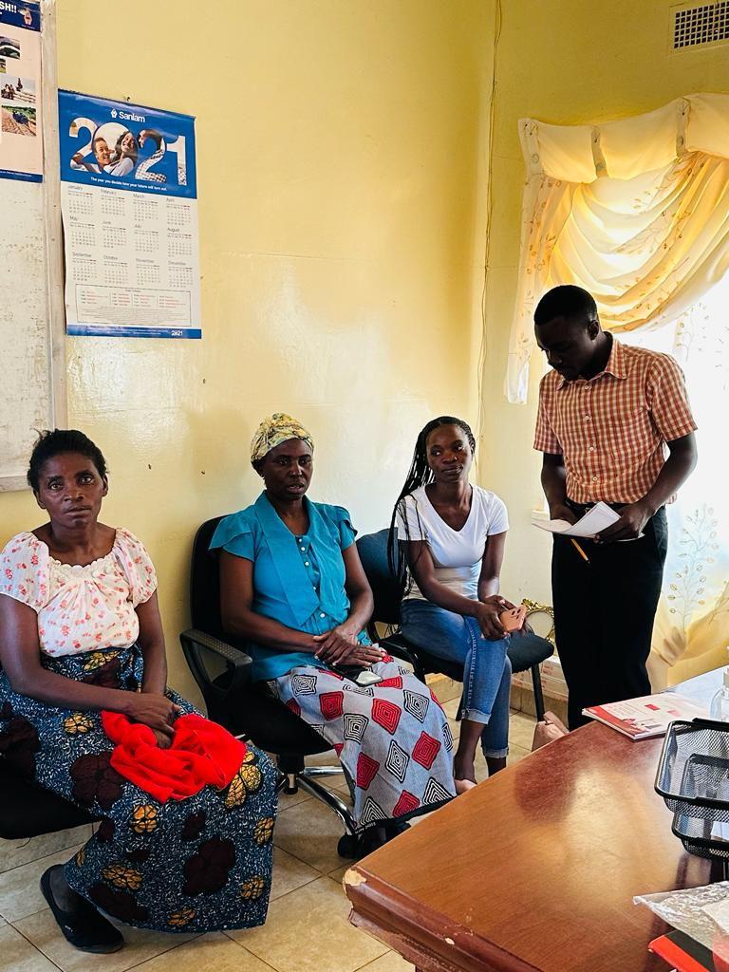

# Impact Assessment

This section presents the evaluation findings on the anticipated impact of the planned project on the primary and secondary beneficiaries, communities, and at policy level.

|  |
| --- |
| **Key Impact Assessment Question**   * What difference will the proposed interventions make in improving ear and hearing care? |

The training of health care workers and teachers carries the potential for a comprehensive and multi-faceted impact on the healthcare and education sectors, as well as the broader community, particularly within the context of ear and hearing care. There is the potential for an enhanced ability to identify early signs of ear and hearing problems among children and adolescents, enabling timely intervention to prevent the progression of hearing impairments. Moreover, the extension of ear and hearing care services into the educational settings, increases accessibility for a broader and more diverse population, including underserved communities.

These trained professionals will have the potential to raise awareness about the importance of and encourage the community members to prioritize preventive measures and seek regular ear and hearing care services. Additionally, there is potential for improved educational performance resulting from improved ear and hearing health by learners with hearing impairments who will receive timely care. They will be better positioned to excel academically, leading to better educational outcomes and ultimate quality of life. Greater awareness of the ear and hearing care services in the community will help alter and demystify prevailing stigmas about ear and hearing care problems in communities.

Consequent uptake in seeking ear and hearing care services, will lead to a reduction in health disparities as children, regardless of their background or location, will have the potential for equal access to early intervention and support with ear and hearing care. Furthermore, the potential extends beyond the immediate project timeline, potentially promoting sustainability. Trained professionals, now well-versed in ear and hearing care, may potentially continue to provide vital services and education, ensuring a long-lasting and positive influence on the community.

**Summary of potential impact**

The training of healthcare workers and teachers has the potential to bring about a wide-ranging and positive impact on healthcare, education, and communities, particularly in the context of ear and hearing care. Trained professionals can more effectively detect early signs of ear and hearing issues in children, allowing for timely interventions and prevention. By integrating ear and hearing care into educational settings, accessibility is increased, benefiting a diverse population, including underserved communities. Additionally, these professionals can raise awareness about ear and hearing health, leading to greater emphasis on preventive measures and regular check-ups. Improved hearing health may also enhance educational performance. Moreover, this initiative can help reduce health disparities, ensuring equal access to early intervention and support. The influence of trained professionals extends beyond the project timeline, promoting sustainability and lasting community impact.



# 9.0 Sustainability Assessment

This section highlights the key findings relating to the sustainability prospects of the planned project, to ensure continuity of planned activities and longevity of outcomes and anticipated impacts.

|  |
| --- |
| **Key Sustainability Assessment Question**   * To what extent will the positive effects (without further external funding) continue after the end of the project? |

Ensuring the enduring success of the ear and hearing care intervention, as reviewed by the feasibility study, necessitates a comprehensive approach that focuses on the structural, economic, and social dimensions. In terms of the structural aspect, it is paramount to ensure a robust healthcare infrastructure that encompasses specialized ear and hearing care services within Zambia. This entails not only increasing the capacity of healthcare facilities but also the creation of tailored legal and regulatory frameworks specific to this domain. Through the implementation of specialized regulations and standards, the project can lay a solid foundation for the sustained structural viability of the initiative.

From an economic standpoint, the project must prioritize the continuous availability of funding and resource mobilization. This entails diversifying funding sources, including government allocations, international collaborations, and philanthropic backing. While funding for the project is available for four and half years through co-financing form BMZ and CBM, it would be imperative to secure public funding through MOH to ensure sustained maintenance of ENT equipment that the planned project will provide. ENT services would improve significantly and be sustained with government support. Ensuring the allocation of financial resources specifically to ear and hearing care services within the healthcare sector is essential to mitigate the risk of budgetary constraints and financial limitations.

On the social front, the project's long-term sustainability is intricately linked to community engagement, acceptance, and active involvement. The focus should be on enhancing the capacity of local healthcare workers and fostering community participation. By providing training to local healthcare professionals in the field of ear and hearing care, the project is laying the groundwork for building a self-sustaining network of service providers. Additionally, active inclusion of persons with disabilities in the planning and implementation processes fosters inclusivity and empowers those with hearing impairments.

The positive changes that will benefit civil society over the long term encompass a transformation in societal attitudes toward hearing impairments. The project aims to achieve this through community sensitization and awareness campaigns, with the ultimate goal of dispelling stigmas and myths associated with these conditions. This approach should contribute to improved societal acceptance and encourage individuals to seek care without the fear of discrimination. Moreover, the project's emphasis on gender equity in healthcare decision-making can lead to broader societal changes by promoting equal participation and representation.

However, there are risks that could potentially undermine the sustainability of the project's changes, including financial constraints, a lack of dedicated legal provisions, and a possible regression in societal attitudes. To minimize these risks, diversifying funding sources and ensuring that ear and hearing care services have a designated budget allocation within the healthcare sector is essential. Collaborating with legal experts and policymakers to establish clear legal provisions and guidelines for ear and hearing care services can effectively mitigate regulatory risks. The project should also maintain ongoing community sensitization and awareness campaigns to preserve positive changes in societal attitudes and address the risk of reverting to stigmatization and myths.

**Summary of** **Sustainability assessment outcomes**: In conclusion, the sustainability of the results and impacts of the ear and hearing care intervention, as informed by the feasibility study, hinges on a multifaceted approach encompassing structural, economic, and social considerations. By supporting financial resource allocation, community engagement, and capacity building within the target regions, the project is well-positioned to ensure its long-term sustainability. Positive changes in societal attitudes, gender dynamics, and the role of community networks contribute to lasting impacts. Risks can be effectively mitigated through diversified funding sources, legal provisions, and sustained community sensitization efforts, ultimately securing the sustainability of the project's changes in Zambia's ear and hearing care services.

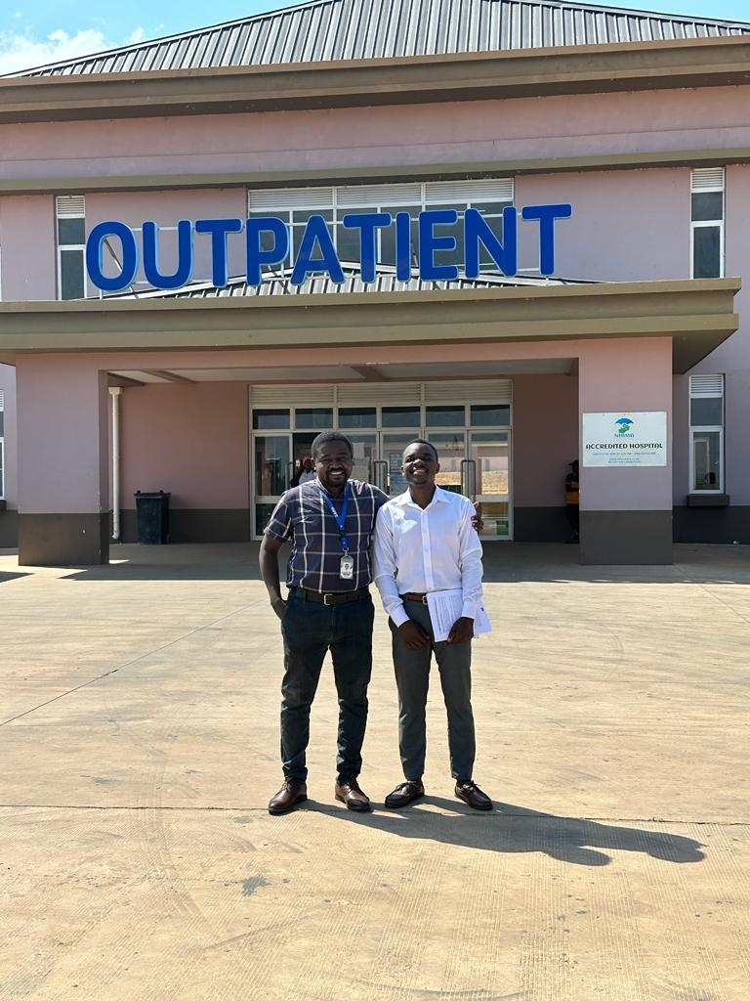

# 10.0 Safeguarding and ethics assessment

|  |
| --- |
| **Key Safeguarding and ethics Assessment Question**   * What considerations will be made to ensure that the program upholds human rights principles, ethics, and addresses stigma and discrimination against people with disability? |

The feasibility study has provided critical insights into safeguarding and ethics assessments. It robustly reinforces the commitment to upholding human rights principles, ethical standards, and the elimination of stigma and discrimination against individuals with disabilities. Within this context, the feasibility study has guided the formulation of a comprehensive set of considerations to ensure the program's alignment with ethical and human rights principles.

A notable recommendation emerging from the feasibility study entails a comprehensive reorientation of all medical staff. This recommendation emphasizes the importance of ethical principles and patient safeguarding, with a particular focus on child protection. Such a measure exemplifies the program's commitment to instilling not only technical proficiency but also an enduring ethical responsibility within the healthcare profession. It is a tangible demonstration of the program's dedication to safeguarding the rights and dignity of all individuals, especially those with disabilities.

To ensure the longevity of ethical practices, the feasibility study underscores the need to integrate ethics and patient protection components into the curricula for nurses and clinical officers. This forward-thinking approach recognizes that enduring ethical practices must be cultivated from the very foundations of the healthcare profession. Through education, healthcare professionals will possess the ethical compass to navigate the complexities of patient care, thus fostering ethical healthcare practices for the long term.

Gender balance and inclusion are cornerstones within the program's ethos. The feasibility study emphasizes the commitment to these principles by promoting equal access to training and ear and hearing care services for all genders. Furthermore, the recommendations emphasize that gender equality must be coupled with comprehensive awareness of child protection and safeguarding policies. This inclusive approach exemplifies the holistic nature of the program's ethical considerations and its commitment to the protection and dignity of all patients.

The feasibility study recognizes the project's solid foundations and its potential for scaling up to a national level. Achieving this broader impact necessitates a strong emphasis on advocacy and lobbying, particularly in the engagement of governmental bodies and relevant authorities. The participation of the Ministry of Health is deemed crucial in the wider implementation of ear and hearing care strategies and policies, ensuring the preservation of ethical and human rights principles.

Child safeguarding is a critical concern highlighted by the feasibility study. The data reveals varying levels of awareness among healthcare staff, with senior personnel demonstrating a high degree of familiarity with child protection and safeguarding policies. In contrast, nurses, clinicians, and speech therapists exhibit a comparatively lower level of understanding. To bridge this awareness gap, the study recommends the integration of child safeguarding policy training within all program sessions. This comprehensive approach is further extended to include the consultancy team, ensuring that ethical and safeguarding principles remain consistently reinforced throughout the program's diverse activities.

The ethical approval was diligently sought and granted for the execution of the feasibility study. This commitment to ethical standards is further emphasized by the acquisition of necessary clearances from UNZABREC and NHRA, along with the additional clearance provided by the Ministry of Health. With these essential ethical approvals in place, the program is fully equipped to proceed with the publication of the report, thereby reinforcing its dedication to transparent and ethical research and reporting practices. Therefore, the data derived from the feasibility study underscores the project's unwavering commitment to safeguarding and ethical considerations. The recommendations for staff reorientation, curriculum integration, and ongoing child safeguarding training reinforce the program's dedication to ethical practices. Gender balance and inclusion are championed, and the program's potential for national expansion is emphasized. Advocacy and lobbying play an indispensable role in expanding program activities, particularly in the integration of ENT services. While child safeguarding awareness varies among staff, this awareness gap will be meticulously addressed through comprehensive training. The acquisition of essential ethics approvals for research and reporting underscores the program's steadfast commitment to ethical practices, human rights, and transparency.

**Summary of safeguarding and ethics:** The feasibility study intricately outlines the program's robust framework, emphasizing safeguarding, ethics, and human rights, particularly for individuals with disabilities. Recommendations include a comprehensive ethical reorientation for medical staff, accentuating child protection, and integrating ethics deeply into healthcare curricula, ensuring sustainable ethical practices. The program champions gender balance and inclusive access to services, necessitating broad awareness of comprehensive safeguarding policies. It highlights the essential role of advocacy and governmental engagement for national scale-up, preserving ethical and human rights standards. Concerns around varied understanding of child safeguarding among staff are addressed through universal training initiatives, extending to all involved teams. The program's commitment to ethical integrity is further cemented by obtaining all requisite approvals for research and public reporting, reinforcing a transparent, ethical, and human-rights-aligned approach throughout its operations.

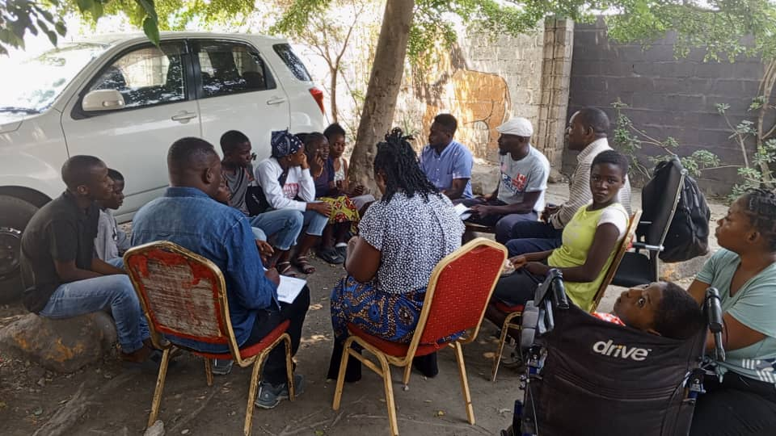

# 11.0 Gender equality assessment

|  |
| --- |
| **Key Gender equality: Assessment Question**   * What considerations will be made to ensure that the program upholds human rights principles, ethics, and addresses stigma and discrimination against people with disability? |

Both Beit Cure Hospital and CBM have in place policies to ensure gender equality is achieved and human rights are respected. Christian Blind Mission has a policy which explicitly states that CBM operates under the norms and standards of international human rights law and the governing national laws in the countries where they operate. This commitment ensures that the programs implemented by CBM and its partners adhere to fundamental human rights principles. Moreover, CBM is committed to promoting greater understanding and application of key international conventions and treaties, including the Convention on the Rights of Persons with Disabilities (CRPD), the Convention on the Elimination of Discrimination Against Women (CEDAW), and the Convention on the Rights of the Child (CRC). These conventions emphasize equality, non-discrimination, and human rights. The program in its BMZ/CBM ENT and planned programs committed to gathering and reporting information by age and sex, therefore monitoring gender specific results achieved.

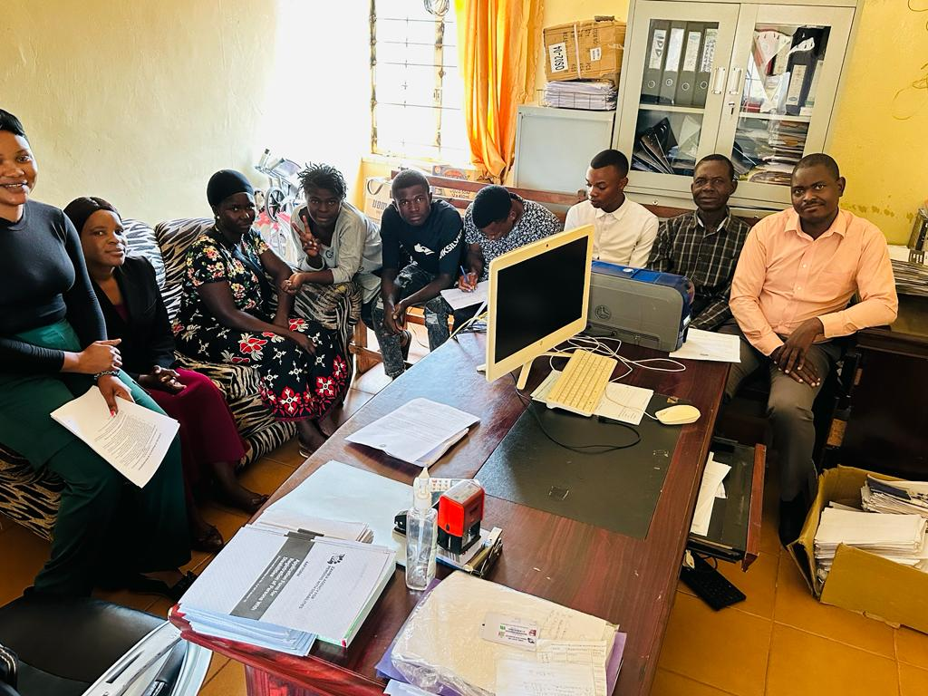

# 12.0 Monitoring and evaluation Assessment

|  |
| --- |
| **Key Gender equality: Assessment Question**   * How will the program measure progress, document and utilize lessons learned and best practices? |

The MOH relies on its Health Management Information System (HMIS) to collect essential healthcare data, including information on ear and hearing care services. However, it has become evident that the number of indicators captured through the HMIS is limited. This limitation raises concerns about the system's capacity to provide a comprehensive overview of ear and hearing care service utilization. Consequently, the feasibility of monitoring progress toward specific ear and hearing care goals within this framework is constrained.

The feasibility of the M&E system for ear and health care services within the current structure is to a large extent, compromised. The limitation in data coverage and indicators restricts the system's ability to adequately track, assess, and report on ear and hearing care-related activities. Without comprehensive data, it becomes challenging to evaluate the impact of interventions or to drive improvements effectively.

To address feasibility challenges within the existing M&E system, the program could enhance data quality by investing in capacity-building efforts. This includes staff training, data validation checks, and improved data collection tools. Moreover, the program, working together with MOH, can simplify and streamline reporting and analysis processes within the current M&E system. This will make data collection and utilization more efficient, eliminating the need for a parallel system. The program can also explore opportunities for using complementary data sources, such as collaborating with other organizations, leveraging community health workers' data, and tapping into patient records. These processes help strengthen the feasibility and utility of the existing M&E system.

The program can also create regular monitoring and feedback mechanisms to assess data collection and reporting effectiveness within the current M&E system. Build the capacity of healthcare staff by providing training on data collection, analysis, and reporting. Establish feedback loops to ensure active data use and promote continuous improvement. This fosters a culture of evidence-based practice within the existing system, making data-driven decisions and actions a norm.

**Summary of feasibility of the monitoring and evaluation system**

The Ministry of Health (MOH) relies on its Health Management Information System (HMIS) to collect vital healthcare data, including information on Ear, Nose, and Throat (ENT) services. However, the system's limited capacity to capture a comprehensive set of indicators has raised concerns regarding its ability to offer a holistic view of ENT service utilization and to monitor progress toward specific healthcare goals in this domain. Consequently, the current Monitoring and Evaluation (M&E) system for ENT services faces challenges in providing effective oversight. To mitigate these limitations, the program can improve data quality through capacity-building efforts, streamline reporting processes in collaboration with the MOH, explore complementary data sources, and establish regular monitoring and feedback mechanisms. This holistic approach aims to strengthen the feasibility and utility of the existing M&E system, fostering a culture of evidence-based practice within the healthcare infrastructure.

# Lessons learnt from the BMZ/CBM ENT and other projects.

**Stakeholder engagement**: Effective stakeholder engagement is a crucial lesson learned from the evaluation of the project. This lesson highlights the importance of involving key stakeholders at the very beginning of a healthcare project, especially one involving the community and local structures in health and education sectors. The MOH is a central authority in healthcare delivery in Zambia. Engaging with this ministry during the project's conceptualization and planning stage is essential. Their involvement ensures alignment with national healthcare priorities, policies, and regulations. Moreover, collaboration with the ministry helps in securing necessary support and resources, such as funding and regulatory approvals. MOH was highly engaged at all level. The engagement of government structures through the Office of the National Coordinator for ENT is not only feasible but fundamental to the healthcare initiatives under review. The government's active participation, facilitated by the National ENT Coordinator, has greatly impacted the projects, making them more efficient, informed, and influential. Moving forward, the sustained support and collaboration of government entities will remain a cornerstone of the feasibility and success in the ever-evolving landscape of healthcare innovation.

**Awareness Raising:** The lesson emphasizes that many beneficiaries of the project were unaware of the existence of ENT services before seeking assistance at the facility. This points to a significant information gap within the community. Inadequate awareness can lead to delays in seeking treatment, especially in cases where early intervention is crucial. Consequently, one of the key takeaways is the importance of proactively addressing this lack of awareness. Awareness raising should be done through outreach efforts to inform the target population about the availability, benefits, and accessibility of ENT services. What works best, as emphasized by stakeholders engaged, are means such as community education programs, public health campaigns, and collaboration with local healthcare providers. Collaborations with local organizations, schools, religious institutions, and other community stakeholders can enhance the reach and effectiveness of awareness-raising efforts. These partnerships can leverage existing networks and resources to maximize the impact of the project. These efforts should aim to educate communities about common ENT issues, when to seek medical assistance, and where to find appropriate services.

*“…We now have, I think, 10 community-based radio stations. We can use these [radio] platforms. Other than that, we can use our extension officers to mainstream the issues of disability. In all the activities we do, when we have people around, we do a lot of community meetings. We have to ensure that [in] every meeting we are telling people about [ear and hearing care].”* ***KII, Provincial Social Welfare Officer.***

**Procurement of Medical Equipment**: The process of choosing and acquiring medical equipment for ENT services should be a collaborative effort, actively engaging healthcare professionals and support staff who will be utilizing the equipment. This active participation holds significant importance for several key reasons. Firstly, healthcare professionals and technicians who work with ENT equipment possess an intimate understanding of the specific needs and requirements within clinical settings. Their insights are invaluable in determining the precise equipment necessary to provide high-quality care effectively. Secondly, involving end-users in the selection process ensures that the chosen equipment is user-friendly and ergonomically designed. This not only enhances usability but also contributes to the overall comfort and efficiency of the healthcare staff using the equipment. Thirdly, it is crucial that the selected equipment aligns with established clinical practices and guidelines. Healthcare professionals can play a pivotal role in identifying equipment that seamlessly integrates with existing protocols and workflows, thus promoting consistency and adherence to established standards.

**Equipment Maintenance and Calibration:** Supplying equipment is key in ensuring that quality ENT services are provided. However, the equipment has to be serviced regularly to ensure that they remain effective and accurate. Moreover, the project discovered the need for a strategy to calibrate equipment, particularly in the audiometric booth. Many of these equipment items become unusable after a specified period. Establishing a calibration site in cooperation with manufacturers could have addressed this issue.

**Essential Drugs Procurement:** The lesson regarding essential drugs procurement in the context of Ear, Nose, and Throat (ENT) services is of significant importance. It highlights a fundamental challenge in ensuring the sustainability of ENT units and their ability to provide essential services in Zambia. Essential drugs usually cover a broad range of medications, predominantly focused on general healthcare needs. However, ENT-specific consumables and medications often fall outside the scope of these essential drug lists. The lesson learned underscores the importance of advocacy and lobbying efforts directed at the Ministry of Health or relevant governing bodies. These efforts are essential to prompt a change in procurement practices. It involves making a strong case for the inclusion of ENT-specific consumables and medications in the list of essential drugs that healthcare facilities can procure. Advocacy may also entail demonstrating the necessity and cost-effectiveness of these items for the overall healthcare system.

**Availability and Affordability of ENT Services:** The availability of ENT-specific services in local health facilities is limited, which creates a bottleneck in the delivery of ENT care. This issue can be attributed to various factors, including the relatively lower prevalence of ENT conditions compared to more common health issues. Even when ENT services are available, they are often unaffordable for many beneficiaries. The cost of these services can be prohibitive, especially for individuals and families with limited financial resources who also have to travel long distances to access specialist ENT care. This financial barrier can deter patients from seeking the treatment they need, potentially exacerbating their health conditions. Recognizing the importance of this lesson, there is a need for advocacy efforts to engage with relevant authorities, including the Ministry of Health, pharmaceutical companies, and healthcare organizations, to address this issue. Collaborative initiatives can focus on distributing resources such as equipment and human resources, negotiating pricing, increasing the availability of medications, and exploring subsidy programs to make essential ENT service accessible and more affordable.

“*…I talked about the lack of services in these big hospitals, provincial hospitals. You realize that ENT [services] in our country [are] only in three hospitals in Ndola, Kitwe and UTH [Lusaka]. These are all in urban areas. We need decentralization of these facilities so that we reduce the distances that people are covering to go to UTH [Lusaka], Ndola or Kitwe Central Hospital [Kitwe].”* ***KII, Provincial Social Welfare Officer.***

**Data Capturing**: Lessons captured from the endline evaluation and key informant interviews emphasize the need for high-quality and comprehensive data, capacity-building, streamlining processes, leveraging additional data sources, and establishing feedback mechanisms to enhance the effectiveness of a healthcare M&E system. The M&E system employed to capture ENT-related indicators faces limitations stemming from various factors. One major issue is the lack of statistics and underutilization of data, which subsequently results in low usage of ENT services. This low utilization further compounds the problem by limiting the M&E system's ability to capture quality ENT-related data effectively. To overcome these feasibility challenges in the M&E system, it is essential to prioritize capacity-building efforts. This encompasses activities such as training healthcare staff, implementing data validation checks, and supplying improved data collection tools. By investing in capacity-building, the M&E system can be better equipped to manage and utilize data effectively.

**Summary of** **Lessons Learnt:** Effective stakeholder engagement, especially with health ministries, is critical for aligning with national healthcare priorities and securing support. Awareness raising within communities is essential due to significant gaps in knowledge about ENT services, highlighting the need for proactive outreach and education. Utilizing existing healthcare personnel for training optimizes resource use, while strategic budget planning, as demonstrated by Beit Cure Hospital’s role, enhances project feasibility. Challenges like overburdening health systems, service accessibility inequities, potential stigmatization, data privacy issues, and creating unsustainable dependencies are identified as areas for attention. The project’s duration, following previous successful models, suggests adequacy for training and implementation. Emphasizing public-private partnerships, technology integration, and incorporating holistic counseling services are additional strategies to enhance effectiveness, with a focus on adaptable strategies and robust indicators to ensure efficiency and achievement of healthcare objectives.Top of Form

# 14.0 Conclusions and Recommendations



## 14. 1 Conclusions

The key findings of the feasibility study for the ear and hearing care project in Zambia reveal a pressing need for improved ear and hearing healthcare services in the country. The study highlights deficiencies at every level of the healthcare system, from a shortage of specialized professionals to inadequate infrastructure and medical equipment. It identifies a diverse array of stakeholders, each playing a crucial role in the project's success, including individuals with hearing impairments, OPDs, MoH Coordinating Committees, implementing partners, government authorities, healthcare facilities, schools, the Department of Social Welfare, and civic and traditional leaders. The needs assessment underscores the universal impact of hearing loss, emphasizing the lack of specialized interventions and unique challenges in both rural and urban areas, as well as gender and age-specific needs. The current healthcare infrastructure is evaluated, revealing limitations in rural areas, a shortage of specialized professionals, technological disparities, and financial constraints. Zambia's policy and legal framework demonstrate commitment to disability rights but face challenges in implementation and awareness. The feasibility study also identifies various risks affecting the project, including transportation challenges, workforce shortages, supply chain disruptions, and cultural beliefs causing discrimination. Cultural and social factors, such as stigma and traditional healers, are emphasized as important considerations.

In terms of relevance, the project aligns well with the needs of the affected communities and international standards, marking a paradigm shift in health interventions. Coherence assessment findings highlight the project's synergy with existing healthcare and education frameworks, emphasizing collaboration, evidence-based practice, and partnership-building. Effectiveness assessment findings indicate a plausible theory of change but also identify potential risks and areas for improvement, such as additional activities and refined indicators. Efficiency assessment findings highlight the project's meticulous budgeting and efficient use of existing resources and personnel. Impact assessment findings underscore the project's potential to significantly impact ear and hearing care, extending its reach to broader community sectors. Sustainability assessment findings emphasize a multifaceted approach to ensuring long-term sustainability, including structural, economic, and social considerations. Safeguarding and ethics assessment findings stress the project's commitment to ethical integrity and human rights. The gender equality assessment highlights policies and data collection practices that promote gender equality. Finally, the monitoring and evaluation system assessment identifies challenges with the existing system and suggests improvements to strengthen its feasibility and utility. Lessons learned from the BMZ/CBM ENT phase underscore the importance of early stakeholder engagement, awareness-raising, procurement considerations, equipment maintenance, advocacy efforts, and effective data capture in healthcare monitoring and evaluation**.**

## 14.2 Recommendations

1. **Addressing potential overburdening of existing health systems:** To mitigate the overburdening of existing health systems with new activities, a two-pronged approach is essential. Firstly, strategic resource management should be prioritized, involving a detailed assessment of current resources and careful task-shifting with support such as additional training and temporary staffing. Investing in technology, like electronic health records and telehealth, can also streamline processes and alleviate facility pressure. Secondly, activities should be incrementally implemented, starting with piloting to assess capacity and impact, and supported by collaborations for resource sharing. Additionally, establishing feedback mechanisms for continuous improvement and providing staff with mental health resources, stress management tools, and professional development opportunities are crucial for maintaining staff well-being and system efficiency.
2. **Addressing potential inequity in service accessibility**: To address the inequity in service accessibility for specialized ear and hearing care, a mobile healthcare model complemented by telehealth services is recommended. This approach involves deploying mobile clinics equipped with necessary medical equipment and staff to remote and underprivileged areas, thereby extending the reach of healthcare services beyond fixed project sites. This method has proven effective in regions like rural India and parts of Africa, where mobile health clinics significantly improved access to medical care. Additionally, integrating telehealth allows patients in these remote areas to consult with specialists via video conferencing, a strategy that has successfully enhanced healthcare access in Australia's rural regions. Adopting this combined mobile and telehealth approach ensures equitable healthcare distribution, addressing the disparities and sense of neglect in communities outside the project's immediate catchment areas.
3. **Addressing potential stigmatization:** To mitigate the risk of stigmatization in projects focusing on individuals with hearing impairments, adopting an inclusive communication and education strategy is recommended. This strategy should involve portraying hearing impairments as one of many normal variations in human experience, rather than a defining characteristic that sets individuals apart. Campaigns and educational programs should emphasize the diverse abilities and contributions of people with hearing impairments, showcasing them in various roles and activities that resonate with the broader community. An example of this approach's effectiveness is seen in the "Like Me" campaign in the UK, which successfully reduced stigma around mental health by featuring relatable stories of individuals from all walks of life. Similarly, in the United States, campaigns by organizations like the National Association of the Deaf have effectively used inclusive messaging to promote a more nuanced understanding of deaf culture and abilities, helping to shift public perception. By focusing on inclusivity and commonalities rather than differences, such strategies can significantly reduce the risk of stigmatization and promote a more inclusive view of individuals with hearing impairments.
4. **Addressing data privacy concerns:** To address data privacy concerns in the collection and handling of medical data, implementing a robust data protection framework is essential. This framework should include strict adherence to data protection laws, regular staff training on confidentiality and ethical handling of data, and the use of secure, encrypted data systems. An example of this approach in practice is the European Union’s General Data Protection Regulation (GDPR), which has set a high standard for data privacy, including in healthcare. Hospitals and research institutions across the EU have successfully adopted these regulations, demonstrating improved patient trust and data security. In addition, employing technologies like blockchain for data storage and access can further enhance security and transparency, as seen in Estonia's healthcare system, which uses blockchain to ensure the integrity and confidentiality of patient records. By adopting these measures, healthcare projects can safeguard patient data, uphold ethical standards, and maintain public trust in their services.
5. **Addressing unsustainable dependency** To prevent unsustainable dependency in healthcare projects, a strategy focusing on capacity building and empowerment is key. This approach involves training local healthcare providers and investing in community-based health initiatives to foster self-reliance. For example, the project can gradually shift from providing direct services to supporting local health systems in developing their own capacities, such as by training local ENT specialists or investing in local production of essential medical supplies. This method has been successfully implemented in various global health initiatives, like the HIV/AIDS programs in sub-Saharan Africa, where a shift from international aid to local capacity building led to more sustainable healthcare systems. Additionally, creating a step-down model for incentives, where external support is gradually reduced over time, can help service providers adjust and find alternative funding sources or incentives. By focusing on building local capabilities and reducing reliance on external resources incrementally, healthcare projects can ensure long-term sustainability and continuity of care even after the project phases out.
6. **Community Led Monitoring:** Implement a community-led monitoring system using community level stakeholders such as Community Health-workers, WDC, CWACS and teachers trained to collect data via user-friendly digital tools (like mobile apps or SMS reporting). This approach has proven in Zambia on other health programmes by organizations like DAPP. It ensures cost-effective, timely data collection with effective feedback loops through regular community forums and digital dashboards, enhancing transparency and stakeholder engagement.
7. **Enhancing specificity of qualitative indicators**: Define qualitative indicators more concretely by establishing clear criteria or benchmarks. Use tools like structured surveys or assessment scales to quantify aspects like "participation at family and community level," ensuring that these indicators are both specific and measurable.
8. **Ensuring measurability and achievability of outcomes**: For outcomes like "strengthening deaf and hard of hearing organizations," set specific, measurable objectives (e.g., number of training sessions conducted, increase in membership, etc.). Ensure data collection feasibility by adopting practical methods and technologies, like digital tracking for neonate universal hearing screening.
9. **Incorporate counselling and support services**: Establish counselling units within ear and hearing care facilities and outreach programs to support individuals and families dealing with hearing loss. This should include family counselling, educational guidance for children, and career counselling for adults. Additionally, train staff in crisis intervention, conduct community awareness programs to combat stigma, and provide continuous training for counsellors, ensuring a comprehensive support system that enhances the quality of life and community understanding for those with hearing loss.
10. **Leverage Corporate Social Responsibility for Enhanced Partnerships**: Initiate public-private partnerships by engaging with corporations in technology and healthcare sectors under their Corporate Social Responsibility (CSR) initiatives. This collaboration can bring advanced hearing aid technology, additional funding, and expertise to the project. Additionally, partner with local and international NGOs to access extra resources and technical know-how. These partnerships, rooted in CSR, can harness private sector innovation and expertise, resulting in more effective, sustainable service delivery and extended support beyond the project cycle.
11. **Expand stakeholder engagement**: Actively involve local authorities, Ward Development Committees, Community Welfare Assistant Committees, and the Department of Social Welfare in the stakeholder base. Additionally, engage with the private sector to harness its expertise and resources. This broader, inclusive stakeholder approach ensures diverse perspectives, enhances community involvement, integrates social welfare considerations, and leverages private sector capabilities for a more comprehensive and sustainable project implementation.
12. **Operationalize 'quality of life' improvements**: The overall objective of the planned project is to contribute to a better quality of life for people living with, or at risk of acquiring hearing loss, through improved access to a continuum of care. There is need to operationalize "quality of life" improvements. This includes establishing clear metrics for what "quality" and "access" entail, ensuring these are reflective of the target groups' specific needs and aspirations.
13. **Develop a comprehensive and inclusive EHC awareness strategy**: Implement a multifaceted awareness approach ensuring gender sensitivity and inclusivity across different age groups and locations. In rural areas, utilize local radio for call-in programs and integrate awareness into community gatherings, outreach, church programs, and schools, leveraging community leaders as advocates. In urban settings, employ TV and radio campaigns, edutainment, school events, and social media to engage a broader audience, including the youth. Place informative posters in key public and private spaces. Throughout these efforts, tailor content to address the evolving needs and preferences of different genders and age groups, and continuously adapt strategies based on community feedback, ensuring the campaign is effective and resonant across the diverse populations in the target provinces.

# Appendices

## Appendix 1: Feasibility Study Process

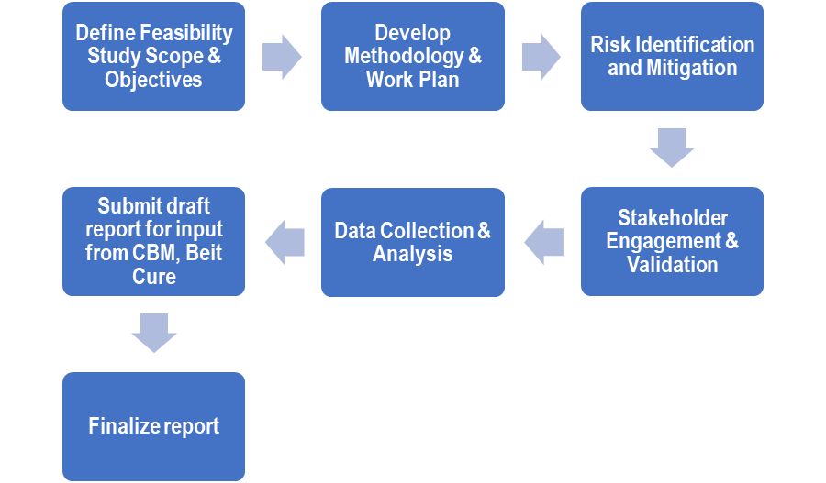The feasibility study for the planned project on "Strengthening Integration of People-Centred Ear and Hearing Care in Zambia" followed a systematic and comprehensive process. It began with the inception phase, where the project's objectives and scope were defined. This was followed by study design and planning, including the identification of key methodologies and resources needed. Desk research was conducted to gather existing information, and fieldwork involved data collection from relevant stakeholders. Comparative analysis helped assess best practices and alternatives, while financial analysis evaluated the project's economic viability. Expert consultations provided valuable insights, and data analysis synthesized findings. Reporting and presentation of Draft 1 captured the study's essence, and addressing comments ensured the final report's accuracy and completeness. This process ensured a well-informed decision-making foundation for the planned project's successful implementation.

Figure 2: Feasibility study Process

## Appendix 2: Reviewed Documents

1. Project Proposal/Concept Note
2. MOH National Ear, Nose and Throat Health Strategic Plan 2017 to 2022
3. MoH eye health strategy (what does is say regarding ear and hearing care?)
4. CBM Strategy 2030 One pager (External)Draft Project concept (PPA will be shared after selection of the successful consultant)
5. Project Budget structure (will be shared after selection of the successful consultant
6. Project evaluation of closed “Strengthening the audiological and ENT services in Zambia 2018-2021.” implemented in Central, Lusaka and Southern Provinces
7. Population based study on the causes and prevalence of deafness and hearing conducted under the above finalised project
8. CBM’s CBID Initiative Plan
9. World Health Assembly Resolution WHA70.13
10. WHO’s World Report on Hearing.
11. Other relevant documents

## Appendix 3: Feasibility Assessment Criteria

The feasibility assessment questions included:

1. **Relevance** - To what extent is the planned project likely to do the right thing?

* Does the planned project approach address a developmental problem or a crucial developmental bottleneck of the partner country or region?
  + What is the prevalence of ear and hearing problems compared to the prevalence of other diseases?
  + Do the health facilities, schools and OPDs planned to be involved in this project and the MoH rate ear and hearing problems as a crucial development bottleneck which needs to be addressed?
* Are the objectives clearly defined and aligned meet the needs of the direct target groups?
* Are norms and standards of the approach for addressing ear and hearing care compatible with the needs of the target groups?
* Is the project designed in a conflict-sensitive way (Do-No-Harm principle)?

1. **Coherence**: How well does the project fit?

* How coherent are the planned activities with human rights principles (inclusion, participation), conventions and relevant standards/guidelines?
* To what extent are there synergies and linkages between the planned project and other interventions by Beit Cure and other actors (e.g. MoH)?
* To what extent does the project add value and avoids duplication?

1. **Effectiveness**: Which project approach can best achieve the objectives?

* Is the impact theory of change plausible?
* What negative effects could occur?
* Is the chosen methodological approach appropriate to the context and sufficient to achieve the project objective?
* Are there additional activities needed to increase the effectiveness?
* Are the indicators appropriate to measure the planned changes?

1. **Efficiency**: Does the use of funds planned by the project appear economical in terms of achieving the objectives?

* To what extent can the planned measures be implemented with the budgeted funds and personnel in the planned duration?
* To what extent are the planned expenditures realistic and the investment costs, operating expenses and personnel costs in proportion to the intended objectives?

1. **Impact**: What difference will the proposed interventions make in improving ear and hearing care?

* What specific contribution does the project objectives (outcomes) make to achieve the overall objective (impact)?
* To what extent does the planned project have a structure-building impact?
* At what levels will norms or structures be changed?

1. **Sustainability**: To what extent will the positive effects (without further external funding) continue after the end of the project?

* How can the sustainability of the results and impacts be ensured and strengthened? (structural, economic, social)?
* What long-term capacities are built up in the target group to enable them to continue the implemented activities on their own?
* What positive changes (role behaviour, mechanisms, networks and others) benefit civil society in the long term?
* Which risks could negatively influence the sustainability of the project changes and how can the risks be minimised?

1. **Safeguarding and Ethics**: What considerations will be made to ensure that the program upholds human rights principles, ethics, and addresses stigma and discrimination against people with disability?
2. **Gender equality**:

* Has a comprehensive gender analysis been conducted as part of the project/program development process?
  + If so, how were the findings and insights from the gender analysis integrated into the project/program design?
* Are data and performance indicators systematically disaggregated by sex and other relevant demographic factors where applicable?
* Is there a commitment to monitor and report on the gender equality results achieved by the project/program?

1. **Monitoring and evaluation**: How will the program measure progress, document and utilize lessons learned and best practices?

In addition, the feasibility study provides:

* Recommendations on any components, measures, approaches that might be missing in the project concept or which might be over ambitious in the given timeframe and budget.
* Recommendations regarding any components or measures where potential negative effects have been identified.
* Recommendations on how to strengthen / increase viability of the cause-effect chain of the project.
* Recommendations on the impact matrix of the project: Anything that can strengthen the clarity of the cause-effect chain of the project.

| **Feasibility Criteria** | **Questions** | **Source** | **Methods** |
| --- | --- | --- | --- |
| **Relevance**  To what extent is the planned project likely to do the right thing?  How well is the proposed project aligned with the identified needs in ear and hearing care in Zambia? | 1. Do people in the community consider ear problems and hearing loss as a significant problem requiring an intervention? 2. If so, how does the problem compare with other health priorities? | Local communities | FGDs |
| 1. How does the program address the specific needs and priorities of children and adults with or at risk of ear problems or hearing loss, including families affected? | Local communities,  HCWs, DEBS  DHO, Beit CURE | FGDs  KIIs |
| 1. Does the program align with the National Ear, Nose and Throat (ENT) Health Strategic Plan in Zambia? | National ENT Strategic Plan 2017-2021 | Document review |
| 1. What specific policy changes or initiatives will be advocated for in relation to ear and hearing care in Zambia? 2. How will the stakeholders engage with policymakers to ensure their concerns and recommendations are heard? | CBM,  Beit CURE  OPDs | FGDs  KIIs |
| 1. To what extent is government support likely and necessary for the project, and how can the project avoid duplication of efforts and enhance disability mainstreaming in a meaningful way? | PHO, CBM  Beti Cure | FGDs  KIIs |
| **Coherence:**  How well does the project fit?  How well do the various components, interventions, and activities align and work together in a logical and coordinated manner to achieve the desired outcomes? | 1. What are the similarities or intersections between the target groups and the projects of other actors in the same context? To what extent does the project add value and avoids duplication? | Documents review,  CBM,  Beit Cure | KIIs  Documents review |
| 1. Do planned program activities foster gender inclusion and respect for human rights? 2. What policies can be developed or implemented to best engage with people with disabilities, children and other participants in a dignified way, observing human rights principles? | Documents review  OPDs, DHO  DEBS | KIIs  Documents review |
| 1. How can the program ensure that stigma and discrimination against people with disability is reduced or ended? | OPDs  Community members | KIIs  FGDs |
| 1. What is the added value of the project in supporting local health sector coordination structures? 2. How can communities, Civil Society Organizations, Youth Groups, and organizations of persons with disabilities be involved? | Documents review  OPDs  DHO  DEBs | KIIs  Documents review |
| 1. Who are the relevant stakeholders responsible for ear and hearing care coordination, and what is their role in the project? 2. How can cooperation be fostered to integrate the project into the National Development Plan? | Documents review  Beit Cure  CBM | KIIs  Documents review |
| **Effectiveness**  Which project approach can best achieve the objectives?  Whether the interventions and activities proposed will successfully achieve the desired outcomes and generate a positive impact. | 1. Are there existing healthcare facilities and schools with capacity, both human resources, equipment and other logistics, to screen people with or at risk of acquiring hearing loss through community outreach and school screening? 2. If not, what is capacity is needed to establish or upgrade facilities and schools to support school screening and community outreach? 3. Are there screening rooms, laboratories or testing facilities available for conducting necessary tests and analyses related to ear and hearing conditions? | DHO  PHO  DEBS | KIIs |
| 1. Do the necessary medical equipment and technologies for ear and hearing care exist and are they accessible in health facilities? 2. If so, is there a plan to maintain, and regularly update the required equipment? 3. If not, is there a plan to procure the required equipment? | DHO  PHO (CCS) | KIIs |
| 1. Are standardized protocols and guidelines for ear and hearing care available and suitable for the program's goals? | DHO  PHO (CCS) | KIIs |
| 1. Is there an existing health information system that can be used to track patient records and program outcomes? 2. If so, Can the program's data on ear and hearing care services be effectively captured and managed within the system? | DHIO | KIIs |
| 1. Are mechanisms in place, and if not, what plans exist for monitoring, evaluation, and incorporating feedback to enhance program effectiveness? | Beit CURE  CBM | KIIs |
| 1. What strategies can the program use to meaningfully engage with local communities and individuals affected by hearing loss to ensure their voices are heard in the advocacy efforts? 2. How best can OPDs and people with, or at risk of hearing loss participate in planning and implementation of the program? | OPDs  Beit CURE  CBM | KIIs |
| 1. How many support groups exist for people at risk of, or with hearing loss? 2. What challenges do they face? 3. What lessons have been learnt in the past two years? | OPDs  Beit CURE | KIIs |
| 1. What management practices could potentially derail or promote the project? 2. What measures can be taken to ensure the project's intended outcomes are likely to be achieved? | CBM  DHO  Beit CURE | KIIs |
| **Efficiency**  How well the resources, including financial, human, and material, will be utilized to achieve the desired outcomes? | 1. What would be an optimal management and coordination structure to ensure efficient setup and execution of the program?    1. How should the program be overseen and directed?    2. How will monitoring and evaluation activities support implementation and achievement of stated objectives?    3. How will CBM, and Beit CURE integrate civil servants to provide leadership in the program? | DHO, Beit CURE, OPDs, CBM  DEBS, Documents review | KIIs  FGDs |
| 1. What resources are necessary to implement the proposed ear and hearing care interventions? | Beit CURE, CBM  PHO | KIIs |
| 1. How does the designed ear and hearing care program compare to alternative approaches in terms of efficiency, impact, and feasibility? 2. What programs, past and present, sought to achieve similar objectives, and what lessons can be drawn from them? | Documents review  DHO  Health facility staff | KIIs  Documents review |
| 1. What lessons have been learned from pilot programs that sought to achieve similar goals? 2. How best can those lessons be applied to improve efficiency and effectiveness in the proposed program? 3. What best practices can be adopted from the previously implemented program? | Documents review  DHO  DEBS | KIIs  Documents review |
| 1. What recommendations can be provided to enhance the efficiency of implementing the ear and hearing care program, ensuring effective resource utilization and maximizing outcomes? 2. What recommendations were made from past programs and how best can they be implemented in the proposed program? 3. What factors can hinder or promote the adoption of such recommendations? | Documents review  Beit CURE  CBM | KIIs  Documents review |
| 1. What challenges, opportunities and recommendations can be made from the experience with the pilot program? | Beit CURE | KIIs |
| **Sustainability**  How will the results of the project be maintained after the project ends? | 1. What can be done to sustain the number of trained community health volunteers and health care workers in each capacitated health facility, to ensure continuity of service provision for ear and hearing care? | DHO  Health facilities | KIIs |
| 1. What role and responsibility will be assumed by the local health and education authorities? 2. How can local potentials, structures, and processes be developed and strengthened? 3. What measures and instruments are best suited for utilizing and strengthening local initiatives, community participation, and capacities? 4. How relationships and linkages between local OPDs and line ministries of government be sustained beyond the program cycle? | OPDs  DHO  DEBS | KIIs  Documents review |
| 1. What major factors could potentially influence the achievement or non-achievement of sustainability of the project? | OPDs, DEBS,  DHO, CBM, Beit CURE | KIIs |
| 1. How will the results of the project be maintained after the project ends? | All stakeholders | KIIs  Documents review  FGDs |
| 1. What exit strategy can best achieve a smooth transition from BMZ support to government support? | DHO, OPDs, DEBS,  Beit CURE | KIIs |
| **Impact**  What difference will the proposed interventions make in improving ear and hearing care? | 1. How does the implementation of sustainable ear and hearing care services directly contribute to Zambia's development goals, both at the national level and specifically within the district sites? | Documents review  OPDs | KIIs  Documents review |
| 1. How can the likely life changes to the target population, attributable to the project or contributed by the project, be quantified and qualified? 2. What measurable indicators can be used to quantify the changes in each impact area? | DHO  OPDs  DEBS  Beit CURE | KIIs |
| 1. What are the likely positive and negative, intended or unintended, political, socioeconomic, and environmental effects of the proposed project? | DHO, OPDs, DEBS  Beit CURE | KIIs |
| 1. To what extent will the proposed action contribute to national development priorities and/or shape policy paradigms for the prevention of disabling hearing loss and improved quality of life for people living with disabilities? | OPDs  MoH  Beit CURE | KIIs |
| **Safeguarding and Ethics**  What considerations will be made to ensure that the program upholds human rights principles, ethics, and addresses stigma and discrimination against people with disability? | 1. How will patient data be collected, stored, and protected to ensure privacy and compliance with health regulations and data protection policies? | DHIO | KIIs |
| 1. What can be done to ensure the continued engagement and commitment of government, OPDs, media, and other stakeholders in advocating for ear and hearing care? | CBM, OPDs  Beit CURE, DHO  DEBS | KIIs |
| 1. What considerations should be made to ensure that children, people with disabilities and other program participants’ rights are respected and that they are treated with dignity? | CBM, OPDs  Beit CURE, DHO  DEBS | KIIs |
| 1. What systems can be implemented to ensure feedback and complaints are handled effectively and efficiently during and after program implementation? | CBM, OPDs  Beit CURE, DHO  DEBS | KIIs |
| **Gender equality** | 1. Has a comprehensive gender analysis been conducted as part of the project/program development process?    1. If so, how were the findings and insights from the gender analysis integrated into the project/program design? 2. Are data and performance indicators systematically disaggregated by sex and other relevant demographic factors where applicable? 3. Is there a commitment to monitor and report on the gender equality results achieved by the project/program? | CBM  Beit Cure  DHO | KIIs |
| **Monitoring and evaluation**  How will the program measure progress, document and utilize lessons learned and best practices? | 1. How will the project assess whether the changes are short-term immediate effects or contribute to sustainable long-term improvements in the target population's lives? | CBM, Beit CURE  DHO, DEBS | KIIs  Documents review |
| 1. How will the perceptions and feedback of the target population and other stakeholders be incorporated into the assessment of life changes? | CBM, Beit CURE  DHO, DEBS | KIIs, Documents review |
| 1. What baseline data is available for each indicator before the project's implementation? 2. How will data be collected during and after the project to track changes over time? | DHO, Beit CURE  CBM | KIIs  Documents review |

## Appendix 4: Sample sizes by region

|  |  |  |  |  |  |  |  |  |
| --- | --- | --- | --- | --- | --- | --- | --- | --- |
| **Participants** | **Sample Sizes by Province** | | | | | | | |
| **Central** | **Muchinga** | **Northern** | **Luapula** | **Eastern** | **Lusaka** | **Southern** | **Total** |
| KIIs with Administrators/Planners/ Policy Makers | 5 | 5 | 5 | 5 | 5 | 5 | 5 | 35 |
| KIIs with Community leaders (WDC Committees) | 2 | 2 | 2 | 2 | 2 | 2 | 2 | 14 |
| KIIs with Ward Councilors | 1 | 1 | 1 | 1 | 1 | 1 | 1 | 7 |
| FGDs With teachers (5 participants per school) | 10 | 10 | 10 | 10 | 10 | 10 | 10 | 70 |
| FGDs with healthcare workers (participants) | 4 | 4 | 4 | 4 | 4 | 4 | 4 | 28 |
| FGDs with people with ear or hearing problems (participants) | 11 | 10 | 10 | 10 | 10 | 13 | 10 | 74 |
| FGDs with Caregivers of people with ear and/or hearing problems (participants) | 9 | 8 | 10 | 10 | 10 | 11 | 10 | 68 |
| Total | 39 | 37 | 39 | 39 | 39 | 43 | 39 | 296 |

# Annexes

## Annex 1: Context analysis



## Annex 2: Tools

